Cinephile: A Full-Stack Film Exploration Platform with Machine Learning-Driven Box Office Revenue Prediction
A Project Report Submitted in the partial fulfillment of the requirements for the award of the degree of

BACHELOR OF TECHNOLOGY
In

DEPARTMENT OF COMPUTER SCIENCE ENGINNERING

&

DEPARTMENT OF COMPUTER SCIENCE AND INFORMATION TECHNOLOGY

By

Bhavanam Ritvik Reddy 2520030283

Sinde Vedhanth 2520030004

Mandala Yeshwanth 2520030525

Under the Esteemed Guidance of

Dr Ramya Krishna Assistant Professor
Department of Computer Science and Engineering




K L (Deemed to be) University DEPARTMENT OF COMPUTER SCIENCE ENGINEERING

&

DEPARTMENT OF COMPUTER SCIENCE AND INFORMATION TECHNOL

Declaration

The Project Report entitled “Cinephile: A Full-Stack Film Exploration Platform with Machine Learning-Driven Box Office Revenue Prediction” is a record of Bonafide work of BHAVANAM RITVIK REDDY - 2520030283 , SINDE VEDHANTH - 2520030004, MANDALA YESHWANTH - 2520030525 submitted
in partial fulfillment for the award of B. Tech in Computer Science and Engineering (or) Computer Science and Information Technology to the K L University. The results embodied in this report have not been copied from any other departments/University/Institute.

BHAVANAM RITVIK REDDY– 2520030283 SINDE VEDHANTH 2520030004
MANDALA YESHWANTH – 2520030525

K L (Deemed to be) University

DEPARTMENT OF COMPUTER SCIENCE ENGINEERING

&
DEPARTMENT OF COMPUTER SCIENCE AND INFORMATION TECHNOLOGY

CERTIFICATE

This is certify that the mini project based report entitled“Cinephile: A Full-Stack Film Exploration Platform with Machine Learning-Driven Box Office Revenue Prediction” is a bonafide work done and submitted by BHAVANAM RITVIK REDDY- 2520030283
, SINDE VEDHANTH- 2520030004, MANDALA YESHWANTH- 2520030525
in partial fulfillment of the requirements for the award of the degree of BACHELOR OF TECHNOLOGY in Department of Computer Science Engineering, K L (Deemed to be University), during the academic year 2024-2025.

Signature of the Guide

Signature of the Course Coordinator Signature of the HOD

ACKNOWLEDGEMENT
The success in this project would not have been possible but for the timely help and guidance rendered by many people. Our wish to express my sincere thanks to all those who has assisted us in one way or the other for the completion of my project.

Our greatest appreciation to my Course Coordinator Dr Ramya Krishna, and my guide Dr Ramya Krishna, Department of Computer Science which cannot be expressed in words for his/her tremendous support, encouragement and guidance for this project.

We express our gratitude to Dr. P Venkateshwara Roa (CSE)/Dr. Kaja Shareef (CSIT), Head of the Department for Computer Science Engineering/ Department for Computer Science and Information Technology for providing us with adequate facilities, ways and means by which we are able to complete this project-based Lab.

We thank all the members of teaching and non-teaching staff members, and also who have assisted me directly or indirectly for successful completion of this project. Finally, I sincerely thank my parents, friends and classmates for their kind help and cooperation during my work.

BHAVANAM RITVIK REDDY – 2520030283 SINDE VEDHANTH – 2520030004
MANDALA YESHWANTH– 2520030525

Abstract

The Content Item Management & Analytics Portal for Media & Entertainment is a web- based platform designed to digitize and streamline the management of digital media content. Media and entertainment organizations often handle a large number of content items such as movies, web series, television programs, trailers, and other digital assets, making it difficult to efficiently organize, track, and analyze content using traditional methods.

The proposed system provides a centralized platform for managing content items throughout their lifecycle, from creation and review to publication and archival. Subscribers can register and access content according to their assigned roles and permissions. The system provides powerful search and filtering capabilities to help users quickly discover relevant content. A recommendation feature can further assist subscribers in discovering content based on available content information and user activity.
In the modern entertainment era, cinematic content is produced at an unprecedented scale across global theatrical industries and streaming services. However, casual film enthusiasts and dedicated cinephiles face severe information fragmentation—navigating disparate websites to discover new releases, view trailers, check box-office revenue trends, and read trustworthy community critiques. This fragmented approach diminishes user experience and creates cognitive fatigue.
To address these challenges, this project presents the Design and Development of Film Buff, a unified, full-stack cinematic web platform that consolidates movie exploration, financial box-office analytics, community reviews, and personalized watchlists into a cohesive single- window interface. Built on a decoupled multi-tier architecture, the platform features a reactive, modern frontend developed using React.js, Vite, and Tailwind CSS, coupled with an enterprise-grade backend built with Java and Spring Boot. Data persistence is managed through a relational MySQL database using Spring Data JPA/Hibernate, while real-time global movie metadata is seamlessly aggregated from The Movie Database (TMDB) RESTful API. User security is enforced using Spring Security, JSON Web Tokens (JWT), and BCrypt password encryption. The system delivers sub-second response times, cross- device responsiveness, and a rich dark-themed UI engineered for visual immersion. This report presents the full engineering lifecycle—from architectural design and database modeling to implementation, integration testing, and performance optimization.

Index

S.  No. | Chapters | Topics | Page.no
 |  | Acknowledgement | 4
 |  | Abstract | 5
1 | Introduction | - Background of the project  - Problem statement  - Scope of the project  - Objective(s)  - Importance of the application  - Target users/audience | 8-14
2 | System Requirements | - Hardware requirements  - Software requirements  - Development tools and frameworks | 15-16
3 | Technology Stack | - Front-end (e.g., React.js, Angular, HTML/CSS)  - Back-end (e.g., Node.js, Django, Spring Boot)  - Database (e.g., MongoDB, MySQL, PostgreSQL)  - Version Control (e.g., Git, GitHub)  - APIs or External services (e.g., Firebase, Stripe) | 17-21
4 | System Architecture | - High-level architecture diagram  - Description of each layer (frontend, backend, database)  - Deployment architecture (e.g., cloud, local, CI/CD pipelines) | 22-23
5 | Design | 5.2 ER Diagram / Database schema | 24
6 | Implementation | - Module-wise implementation  - Front-end logic (UI rendering, state management)  - API integration  - Authentication & Authorization | 25-29
7 | Features | - List of main features  - How each feature works (user perspective + technical description) | 30-32
8 | Testing | - Postman testing (frontend/backend)  - Integration testing  - Tools used for testing  - Test cases and results | 33-36
9 | Deployment | - Steps to deploy  - Environment configuration  - Hosting of frontend and backend | 37-39
10 | Challenges & Limitations | - Issues faced during development  - Solutions applied  - Current limitations or known bugs | 40-41
11 | Future Enhancements | - Planned features  - Possible integrations or optimizations | 42-44
12 | Conclusion | - Summary of the project  - What was achieved  - Skills learned during development | 45-47
13 | References | - Books, tutorials, APIs, documentation sites used | 48-49

14 | Appendices | - Screenshots of the app  - Sample code snippets  - Installation/setup instructions  - User manual or guide  -Geo Tag photos with guide  -Review forms with guide signatures | 50-55

CHAPTER -1 INTRODUCTION

Background of the Project

Proliferation of Streaming and Theatrical Releases: The exponential growth of global film production across theatrical distribution and OTT platforms has created an unprecedented volume of cinematic content available to consumers worldwide.
Shift Toward Digital Media Discovery: Traditional channels of movie discovery—such as print magazines, linear television guides, and word-of-mouth recommendations—have been largely superseded by interactive web platforms.
Severe Information Fragmentation: In the current digital landscape, cinema data is scattered across isolated silos; users must consult one platform for trailers, another for release dates, and a third for critical reviews.
Neglect of Box-Office Intelligence: Existing consumer movie portals frequently omit commercial context, leaving film enthusiasts without accessible tools to view territory breakdowns and theatrical gross statistics.
Rise of Globalized Cinema: Audiences increasingly consume international, non-English cinematic works, necessitating platforms that offer comprehensive metadata, multilingual tagging, and cross-cultural ratings.
Data-Intensive Nature of Cinema Platforms: Movie tracking services require high-volume data ingestion, fast relational mapping, and the ability to process multi-attribute search queries without latency.
Demand for Modern Single Page Applications (SPAs): Contemporary web users expect instantaneous, desktop-like browsing experiences without the latency of repeated full-page browser reloads.
Advancement of Component-Based UI Frameworks: Modern frontend libraries like React have revolutionized the creation of dynamic, reusable, and state-driven user interfaces.
Evolution of Utility-First CSS: Modern web design has shifted toward utility-first styling systems like Tailwind CSS, enabling dark-themed, immersive interfaces suited for entertainment media.
Maturity of Enterprise Java Ecosystems: The Java and Spring Boot ecosystem has established itself as an industry benchmark for constructing scalable, type-safe, and resilient RESTful microservices.
Relational Database Reliability in DBSE: Structured data management via relational systems (such as MySQL) remains fundamental for ensuring ACID compliance in user accounts and data consistency.
Emergence of Global Movie Repositories: Open, standardized registries like The Movie Database (TMDB) provide REST APIs that expose live film metadata, production credits, and media assets.
Vulnerabilities of Legacy Session Management: Traditional server-side session cookies face security vulnerabilities and scaling bottlenecks, driving the adoption of stateless token- based architectures.
Security Standardization with JSON Web Tokens (JWT): The adoption of cryptographically signed JWTs allows decentralized, stateless authorization across distributed API endpoints.

Importance of Strong Password Cryptography: Rising cybersecurity threats demand industrial-strength one-way hashing algorithms, such as BCrypt, to safeguard user credentials. User Fatigue from Ad-Saturated Platforms: Mainstream commercial film portals are often cluttered with advertisements, sponsored banners, and tracking scripts that degrade the viewing experience.
Need for Democratic Community Feedback: Casual cinephiles require community-driven rating and review systems that prioritize authentic audience reception alongside professional critical consensus.
Convergence of Web Engineering Disciplines: Modern software engineering curricula demand practical integration of database design, API orchestration, and responsive interface design into a single system.
Motivation Behind "Film Buff": Film Buff was conceptualized to address these industry gaps by providing an integrated, ad-free, high-performance cinematic ecosystem.
Architectural Synthesis: The platform unifies React 19, Tailwind CSS, Spring Boot, Spring Data JPA, and MySQL into an interconnected, scalable application tailored for film exploration.

Problem Statement

Disjointed User Workflows: Users must switch between three or four disconnected portals to gather basic film data, watch trailers, review cast lists, and read reviews.
Cognitive Overload from Cluttered UIs: Established movie websites present dense, ad- heavy layouts that overwhelm users instead of highlighting essential cinematic information.
Absence of Centralized Box-Office Data: Most casual discovery platforms hide or omit commercial metrics, preventing users from analyzing domestic versus international box- office performance.
Slow Page Navigation in Legacy Systems: Traditional multi-page movie websites trigger repeated server round-trips, causing screen flickering and slow navigation during searches.
Inconsistent Search and Filtering Mechanisms: Many current platforms lack granular filtering, preventing users from querying films by overlapping criteria like year, genre, and rating simultaneously.
Inefficient Mobile Responsiveness: Several legacy film databases are poorly optimized for mobile devices, resulting in distorted layouts, unreadable typography, and truncated data grids.
Security Risks with Sensitive User Data: Unsecured authentication flows and plaintext or weakly hashed passwords expose user accounts to credential stuffing and brute-force attacks. Inadequate API Token Isolation: Improperly architected applications expose third-party API credentials on the client side, risking API quota exhaustion and security breaches.
Lack of Territory-Wise Financial Visualization: The lack of visual territory charts makes it difficult for film students and analysts to evaluate where a film generated its commercial revenue.
Stale and Static Movie Listings: Platforms relying on manual database entry often feature outdated release dates, obsolete cast lists, and broken media links.

Unstructured Review Ecosystems: Many online forums lack structured rating scales, making it difficult to calculate aggregated community sentiment.
Cross-Origin Resource Sharing (CORS) Obstacles: Unoptimized API server configurations frequently block legitimate frontend client requests during distributed or multi- port deployments.
Poor Error Handling and Feedback: When an upstream data provider experiences latency, legacy platforms display uninformative blank pages or raw stack traces.
High Resource Consumption on Mobile Browsers: Unoptimized, uncompressed image assets and unminified scripts cause high data consumption and drain battery life on handheld devices.
Redundant Data Entry for Film Enthusiasts: The absence of a unified personal profile prevents users from maintaining persistent, centralized records of their interactions and reviews.
Lack of Visual Hierarchy: Crucial details such as the director, key crew members, running time, and certification are frequently buried under secondary trivia.
Complex Deployment and Configuration Hurdles: Many academic full-stack systems fail in local development due to operating-system-specific script parsing and environment mismatches.
Missing Validation on User Registration: Inadequate input validation allows mismatched passwords and invalid email formats to pollute backend databases.
Absence of Unified REST API Standardization: Poorly designed backends fail to provide uniform JSON responses, making client-side state handling brittle and error-prone.
Core Problem Summary: The absence of an integrated, secure, visually refined, and ad-free web platform that seamlessly bridges global film registries with real-time relational persistence.

Scope of the Project

Global Film Discovery Scope: Encompasses thousands of international and domestic titles synchronized through real-time RESTful API integration.
Client-Side SPA Architecture: Implementation of a fast Single Page Application using React 19 and Vite 8 that updates views dynamically without full-page reloads.
Advanced Filtering Engine: Multi-attribute filtering enabling users to isolate films by release year, genre identifiers, user rating thresholds, and popularity metrics.
Granular Movie Metadata Profiles: Provision of detailed dossiers for individual titles, including taglines, plot synopses, runtimes, release statuses, and studio details.
Cast and Crew Directory: Comprehensive visualization of acting credits, character roles, directors, and production crew with associated photography.
Embedded Multimedia Integration: Seamless integration of official high-definition YouTube video trailers and promotional teasers directly within movie views.
Theatrical Box-Office Module: Dedicated analytical dashboards featuring domestic gross, foreign revenue, total earnings, and territory percentage splits.
Relational User Persistence: Design and management of a normalized MySQL relational schema storing registered user credentials and profile metadata.
Stateless Security Architecture: Implementation of Spring Security configured for stateless session management using signed JSON Web Tokens (JWT).

Cryptographic Password Protection: Automated server-side password hashing using the
industry-standard BCrypt algorithm prior to database persistence.
Responsive Multi-Device Support: Ensuring complete UI/UX fidelity across smartphones, tablets, laptops, and ultra-wide desktop monitors via Tailwind CSS v4.
API Gateway and Credential Concealment: Routing all third-party external requests through Spring Boot, keeping private API bearer tokens hidden from the client browser.
Form Validation and Input Sanitization: Dual-layer validation (React client-side checks and Jakarta Validation annotations in Spring Boot) to prevent malformed data entry.
Cross-Origin Configuration (CORS): Flexible CORS origin patterns supporting seamless local development across dynamic ports (localhost:5173, localhost:5174, etc.).
Interactive Rating and Critique System: Component-driven rating selectors (1 to 10 stars) and structured user review submission panels.
Centralized Error Handling: Graceful fallback mechanisms and structured JSON error responses ensuring predictable client behavior under exception scenarios.
Database Transaction Management: Utilizing Spring Data JPA and Hibernate ORM to maintain ACID guarantees during entity creation and query execution.
Modern DevOps and Build Pipeline: Leveraging the Apache Maven wrapper (mvnw.cmd) and Vite build automation for standardized environment deployment.
Exclusions from Current Scope: The initial release does not include commercial payment processing for live theatrical ticketing, physical seat reservations, or video streaming hosting. Summary of Project Scope: A full-stack, enterprise-grade movie intelligence and community portal combining modern reactive interfaces with secure relational backend engineering

Objectives of the Project

Unify Cinema Intelligence: To design a centralized platform that consolidates movie
metadata, multimedia trailers, box-office stats, and community critiques.
Develop a Responsive User Interface: To engineer an intuitive, dark-themed frontend using React 19 and Tailwind CSS that reduces visual clutter.
Ensure Sub-Second UI Rendering: To leverage Vite’s optimized bundling and React’s virtual DOM to achieve rapid page transitions and instant filter updates.
Implement an Enterprise REST Backend: To construct a scalable, maintainable server-side architecture using Java 17+ and Spring Boot.
Establish Relational Data Integrity: To model and deploy a normalized MySQL database schema that guarantees ACID compliance for user accounts.
Seamlessly Ingest Upstream Data: To integrate The Movie Database (TMDB) API using Spring’s modern RestClient to fetch real-time global movie records.
Protect User Credentials: To enforce cryptographic password protection using BCrypt with
automatic salting to eliminate plaintext storage vulnerabilities.
Implement Stateless Authorization: To generate, sign, and validate JSON Web Tokens (JWT) for secure, scalable, and session-independent user authorization.
Conceal Sensitive API Secrets: To act as a secure intermediary gateway, ensuring upstream API tokens and database credentials remain hidden from public client inspection.
Provide Granular Movie Exploration: To empower users with dynamic search and filtering tools based on genre, release date, and minimum rating thresholds.

Visualize Box-Office Trends: To design intuitive analytical components that illustrate commercial performance, profitability, and territory revenue distributions.
Facilitate Community Reviews: To build interactive user review panels and rating mechanisms that allow audiences to express qualitative feedback.
Enforce Dual-Layer Validation: To implement client-side input validation in React and server-side validation using Jakarta constraints (@NotBlank, @Email, @Size).
Deliver a Desktop-Like Experience: To implement client-side routing via React Router v7, eliminating disruptive browser window reloads.
Ensure Cross-Platform Portability: To eliminate platform-specific execution errors across
Windows, Linux, and macOS development environments.
Guarantee Robust Error Resilience: To intercept exceptions globally and return informative, structured HTTP status codes (200, 400, 401, 403, 404, 500).
Standardize API Testing: To validate all endpoints rigorously using Postman collections and automated JUnit 5 test suites.
Eliminate Deployment Path Conflicts: To resolve operating system script parsing bugs (such as Windows cmd.exe ampersand path delimiters).
Demonstrate DBSE Best Practices: To showcase practical mastery of Entity-Relationship modeling, Object-Relational Mapping (ORM), and relational schema management.
Deliver an Extensible Codebase: To construct modular codebases in both frontend and backend layers that facilitate future integrations with machine learning and social features.

Importance of the Application

Elimination of Digital Fragmentation: Combines multiple entertainment services into a single portal, significantly saving time for casual viewers and researchers.
Enrichment of Film Literacy: Broadens viewer appreciation by contextualizing cinematic art with detailed cast filmographies, directorial credits, and historical metadata.
Democratization of Commercial Data: Demystifies box-office economics by presenting transparent gross revenue splits and territory distributions in an accessible graphical format.
Ad-Free User Experience: Prioritizes user focus and content immersion by eliminating sponsored pop-ups, video interruptions, and third-party advertising trackers.
Protection of User Privacy: Strictly limits data collection to core account credentials, ensuring that personal data is never monetized or exposed.
Enhanced Trust Through Cryptography: Leverages industry-standard BCrypt hashing and
cryptographic JWT signatures, providing peace of mind to registered users.
Empowerment of Independent Voices: Provides an open, unweighted review ecosystem where community reviews are displayed alongside mainstream ratings.
Accessibility Across Low-Bandwidth Devices: Employs optimized asset loading, lazy rendering, and responsive utility styling, ensuring accessibility on budget smartphones.
Promotion of Cross-Cultural Cinema: Surfaces trending and high-rated international titles, encouraging users to discover films outside their regional domestic markets.
Educational Utility for Film Students: Offers film scholars and aspiring filmmakers a reliable research tool for analyzing release patterns, runtimes, and box-office dynamics.

emonstration of Multi-Tier Engineering: Serves as a reference implementation of a decoupled modern web application for computer science and DBSE students.
Mitigation of Upstream Rate Limiting: Centralizing API interaction through a Spring Boot gateway prepares the infrastructure for server-side caching, minimizing API consumption.
Fostering a Sense of Community: Lays the foundation for cinephile interaction, collaborative film discussions, and shared movie discovery.
Clean Separation of Concerns: Decoupling the frontend presentation layer from backend business logic allows independent maintenance, scaling, and technology updates.
High Fault Tolerance: Ensures that an intermittent failure in third-party media endpoints does not bring down core application operations or user sessions.
Modernization of Academic Software Projects: Replaces legacy, monolithic academic templates with contemporary industry frameworks (React 19, Spring Boot 4/3, Tailwind v4). Standardization of REST Communications: Demonstrates disciplined adherence to REST architectural constraints, HTTP status conventions, and uniform JSON formatting.
Inspiration for Independent Developers: Demonstrates how small engineering teams can build platforms competitive with commercial services using open-source tools.
Streamlined Personal Curation: Enables film lovers to organize their viewing journeys systematically rather than maintaining disjointed text notes or bookmarks.
Long-Term Industry Relevance: Establishes an adaptable technological foundation capable of evolving alongside advancements in streaming APIs and predictive cinema analytics.

Target Users / Audience
Casual Moviegoers: Individuals seeking fast, reliable recommendations on what to watch during weekends or leisure hours without navigating confusing menus.
Dedicated Cinephiles: Film enthusiasts who closely follow directors, cinematographers,
screenwriters, and production houses across international releases.
Film Studies Students: Academic researchers analyzing narrative genres, release pacing, box-office trends, and cast distribution patterns.
Box-Office Enthusiasts: Data-driven audiences who track opening weekend collections, international market splits, and theatrical commercial profitability.
Streaming Consumers: Audiences overwhelmed by excessive choices across multiple OTT services who need a single curated platform to identify high-quality films.
Community Film Reviewers: Aspiring film critics who want to write detailed reviews, assign star ratings, and build personal credibility among fellow movie lovers.
Mobile-First Users: Commuters and smartphone users who demand an ultra-responsive, lightweight web interface that operates smoothly on mobile browsers.
International Cinema Fans: Viewers interested in discovering regional and foreign-language cinema with accurate translated metadata and original language identifiers.
Entertainment Journalists: Media professionals requiring quick access to verified release
dates, official trailers, casting announcements, and production studio data.
Pop Culture Content Creators: YouTubers, podcasters, and bloggers who need accurate film trivia, runtime information, and financial data for content production.
Family and Group Decision-Makers: Users looking for consensus ratings, family-friendly genre classifications, and plot overviews to coordinate group viewing.
Retrospective Film Buffs: Audiences interested in exploring historical cinema archives, filtering releases from past decades, and rediscovering classic cinema.

Technical Recruiters and Evaluators: Software engineering evaluators examining clean full-stack architectural design, JPA database relationships, and secure API gateways.
Database Systems Instructors: Faculty assessing practical student implementation of normalization, ACID transaction management, and ORM mapping.
Indie Film Enthusiasts: Viewers seeking hidden cinematic gems that may not receive massive marketing pushes on conventional commercial platforms.
UI/UX Design Enthusiasts: Designers seeking an example of clean, dark-mode entertainment interfaces characterized by strong typography and minimal visual clutter.
Festival and Award Followers: Enthusiasts tracking critically acclaimed titles across global film festivals and seasonal award campaigns.
Privacy-Conscious Internet Users: Individuals who deliberately avoid ad-tracking platforms in favor of privacy-respecting, ad-free web utilities.
Casual Entertainment Browsers: Users who simply enjoy exploring visually captivating
film posters, backdrops, and video trailers in an immersive environment.
Future Platform Contributors: Open-source developers and contributors interested in extending the codebase with social feeds, watch-parties, or AI recommendations.

CHAPTER -2 SYSTEM REQUIREMENTS

Hardware Requirements

Hardware specifications establish the physical execution boundaries necessary to design, build, test, and host the Film Buff application efficiently. Because modern full-stack web applications combine asynchronous frontend asset bundling, embedded enterprise application servers, and local relational database engines, the underlying development machine must support concurrent resource-intensive processes. The hardware environment is conceptually split into two categories: the development workstation utilized by software engineers and the client device utilized by general end-users.
For developers, a capable multi-core workstation is essential. The development lifecycle requires running an integrated development environment (IDE), executing the Java Virtual Machine (JVM) hosting Spring Boot, operating Node.js with Vite in Hot Module Replacement (HMR) watch mode, running the MySQL 8.0 relational database daemon, and serving client browser tabs concurrently. The recommended developer processor is an Intel Core i5 or AMD Ryzen 5 (quad-core or higher) with a base clock frequency of at least 2.4 GHz. A minimum of 8 GB of RAM is mandatory, while 16 GB of high-speed DDR4/DDR5 RAM is strongly recommended to prevent memory swapping when running automated test suites alongside database migrations.
High-speed storage is equally crucial during development. Solid State Drives (SSDs) utilizing NVMe or SATA interfaces with a minimum capacity of 256 GB are essential. Fast read and write capabilities significantly reduce Maven dependency indexing, node_modules extraction, and database read/write latency. A Full HD display (1920x1080 resolution) or higher facilitates dual-terminal monitoring—allowing developers to inspect Spring Boot application logs in one terminal while monitoring Vite compilation output in an adjacent pane. Reliable broadband connectivity (10 Mbps or higher) is necessary for continuous TMDB API querying and cloud repository synchronisation.
From the end-user perspective, the hardware overhead is intentionally minimal due to the decoupled client-server architecture. Because the frontend relies on pre-bundled static JavaScript and responsive CSS, users can access Film Buff from standard personal computers, laptops, tablets, or smartphones. Any modern dual-core mobile or desktop CPU (1.5 GHz or higher) accompanied by at least 2 GB of RAM is fully sufficient. A steady mobile 4G/5G or home broadband network connection with a baseline speed of 2 Mbps ensures smooth streaming of embedded YouTube trailers and rapid caching of high- resolution poster artwork.

Software Requirements
The software environment defines the runtime ecosystems, libraries, operating systems, and database engines that power the platform. A clearly specified software stack ensures reproducible builds, prevents dependency conflicts, and establishes stability across diverse operating environments. In Film Buff, software requirements encompass both development- time dependencies and deployment-time runtimes.
At the operating system level, the platform is designed to be cross-platform compliant. Developers can build and execute the application across Windows 10/11, Ubuntu Linux (LTS distributions), or macOS. On Windows platforms, PowerShell and the standard Windows Command Prompt serve as primary execution shells. On the backend, the Java Development Kit (JDK) 17 or higher is mandatory, with the application fully verified and operational on the latest Oracle OpenJDK runtime (Java 26). The Java runtime provides the foundational memory management, garbage collection, and bytecode compilation mechanisms required by Spring Boot.
On the client and build side, the Node.js runtime environment (version 18.x LTS or higher, with testing verified on Node.js v24 LTS) along with npm (version 10+) is required. Node.js functions as the host runtime for Vite, managing package dependencies and compiling modern ECMAScript into optimized client assets. For data persistence, MySQL Server 8.0 acts as the relational database engine, managed through MySQL Workbench or the MySQL command-line client. End users only require an updated, standards-compliant web browser— such as Google Chrome, Mozilla Firefox, Microsoft Edge, or Apple Safari—equipped with an active JavaScript V8/WebKit engine.

Development Tools and Frameworks

Selecting appropriate development tools streamlines coding, debugging, database management, and version tracking. For Film Buff, the primary Integrated Development Environment (IDE) is Visual Studio Code (VS Code). VS Code provides a lightweight, extensible workspace enhanced by specialized extensions: the Extension Pack for Java (providing Language Server Protocol support, code completion, and direct JUnit execution), Spring Boot Tools (facilitating application property completion and actuator insights), and Tailwind CSS IntelliSense (providing inline CSS utility previews and syntax validation).
Build automation and dependency management are handled by dedicated tools on both sides of the stack. For the backend, Apache Maven is managed through the self-contained Maven Wrapper (mvnw.cmd), ensuring consistent Maven versions across developer machines without requiring global system installations. Maven coordinates dependency trees, executes test compilation, and packages the application into standalone JAR archives. For the frontend, Vite acts as the build tool, utilizing native ES modules during development and Rollup for minified production bundling.
Quality assurance, interface design, and version management complete the tooling ecosystem. Postman is employed as the primary API development and testing utility, allowing engineers to craft, simulate, and automate HTTP requests against REST controllers. Git provides distributed version control, tracking changes across local branches and synchronising with GitHub for remote repository backup, pull-request reviews, and collaborative source code maintenance.

CHAPTER-3 TECHNOLOGY STACK

Front-End Design

The frontend of Film Buff is engineered as a high-performance Single Page Application (SPA) prioritizing visual immersion, rapid page transitions, and responsive layout scaling. The presentation layer is built upon React 19, utilizing its declarative component model to structure user interface elements into self-contained, reusable modules. By taking advantage of React’s Virtual DOM diffing algorithms, the interface re-renders only those specific nodes affected by state mutations, eliminating full-page reloads and minimizing browser reflows.
Vite serves as the next-generation frontend build engine. Unlike traditional bundlers that pre- bundle entire codebases before serving, Vite leverages native browser ES Modules (ESM) to deliver near-instantaneous dev server startups and millisecond-level Hot Module Replacement (HMR). During production builds, Vite employs Rollup to optimize and tree-shake JavaScript dependencies, minify code, and split assets into lightweight chunks, ensuring sub-second initial load times even over constrained network connections.
Styling is implemented using Tailwind CSS v4, configured to establish an entertainment- focused dark mode theme. The visual palette combines deep charcoal backgrounds (#101418), elevated surface containers (#1c2024), neon green call-to-action highlights (#00e054), and subtle border dividers (#262626). Fluid layout structures are achieved using modern CSS Grid and Flexbox utilities, providing natural reflow from mobile viewports to ultra-wide desktop monitors without stylesheet bloat.
Asynchronous data fetching and application routing are managed through Axios and React Router v7. React Router enables declarative navigation between the Dashboard, Movie Details, Explore, and Authentication views while maintaining synchronized browser history. Axios handles all HTTP interactions with the backend, incorporating request interceptors that automatically retrieve the user's stored JSON Web Token from localStorage and inject it into outbound Authorization: Bearer headers, guaranteeing secure and seamless communication.

Back-End Design

The backend of Film Buff is designed as an enterprise-grade RESTful API service developed using Java 17/26 and the Spring Boot framework. Spring Boot provides an opinionated application framework with an embedded Apache Tomcat server listening on port 8080. The backend adopts an inversion-of-control (IoC) and dependency-injection (DI) pattern, organizing server code into distinct Controller, Service, and Repository layers that separate concerns and facilitate automated unit testing.
Security is enforced at the network entry point via Spring Security. The system implements a stateless SecurityFilterChain that explicitly disables session cookies and Cross-Site Request Forgery (CSRF) tokens, substituting them with cryptographic token-based authorization. A custom Cross-Origin Resource Sharing (CORS) policy is declared to permit incoming traffic from any local development origin pattern (http://localhost:* and http://127.0.0.1:*). This ensures that client applications operating across different local ports can communicate with the backend without browser-level security blocks.
User authentication is secured using JSON Web Tokens (via JJWT 0.13.0) and BCrypt password encryption. When a client submits valid login credentials, the server generates an HMAC-SHA cryptographically signed JWT token containing user identifiers, issued timestamps, and expiration parameters. On subsequent authenticated calls, Spring Security filters parse and validate the token signature before granting access to protected endpoints. User passwords undergo salted one-way hashing via BCryptPasswordEncoder prior to database storage, protecting user credentials against dictionary and rainbow-table attacks.
Third-party communication is managed through Spring's modern RestClient. Configured within TmdbService, RestClient acts as a secure upstream gateway to The Movie Database (TMDB). It injects server-side API bearer tokens, formats query strings, and handles external GET requests synchronously without exposing private API credentials to client-side inspection.

Database Design

The data management architecture relies on MySQL Server 8.0, an open-source relational database management system (RDBMS) renowned for transactional reliability, referential integrity, and compliance with ACID (Atomicity, Consistency, Isolation, Durability) principles. MySQL manages persistent entity data, ensuring that account registrations, profile changes, and user-generated records remain durable and consistent across unexpected application restarts.
Object-Relational Mapping (ORM) is implemented through Spring Data JPA with Hibernate serving as the underlying persistence provider. Hibernate maps the Java User entity class directly to the MySQL relational table named users. Through Spring Boot’s spring.jpa.hibernate.ddl-auto=update configuration, the database schema is automatically updated upon application startup to mirror entity model changes. Spring Data JPA eliminates redundant data-access boilerplate code by generating runtime implementations of repository interfaces (such as UserRepository), allowing developers to execute operations like findByEmailaddress() and existsByEmailaddress() through derived query methods.
Database connection management is handled by the HikariCP connection pool, recognized for its minimal zero-overhead performance. HikariCP maintains a pool of active database connections, eliminating the performance penalties of opening and closing physical database sockets for every HTTP transaction. The database design adheres to Third Normal Form (3NF), preventing data anomalies and optimizing indexing performance across primary and unique key columns.

Version Control

Version control is central to the project's software lifecycle, providing systematic tracking of source code iterations, branches, and architectural modifications. The platform employs Git as its distributed version control engine and GitHub as its remote cloud hosting repository. Through Git, the complete developmental history of the codebase—encompassing frontend assets, backend Java sources, build configurations, and database properties—is securely versioned.
The repository workflow follows an adapted feature-branch model. Developers isolate distinct units of work—such as frontend styling enhancements, security filter configurations, or TMDB service implementations—into dedicated branches before merging them into the main development branch. This prevents unstable, experimental code from compromising the working codebase. Branch protection rules and semantic commit messages (feat:, fix:, refactor:, chore:) provide an audit trail of architectural decisions and issue resolutions.
To maintain environment security, a .gitignore configuration is enforced across both backend and frontend directories. This prevents the accidental commitment of sensitive files, such as local environment configurations, compiled bytecode (target/), client build directories (dist/), and dependency packages (node_modules/). In addition, GitHub acts as an offsite backup, supporting continuous synchronization and cross-machine development.

APIs or External Services

External APIs provide the data backbone of Film Buff, transforming what would otherwise be a static application into a live movie intelligence ecosystem. The platform integrates The Movie Database (TMDB) API v3, an established global entertainment metadata provider. Through TMDB, the system receives structured, real-time JSON responses containing details on trending films, popular releases, genre taxonomies, cast and crew credits, and video trailers.
The architecture decouples the frontend client from the third-party API by utilizing the Spring Boot backend as a secure reverse proxy and API gateway. Client components never call TMDB endpoints directly. Instead, requests are directed to internal endpoints such as /api/tmdb/trending or /api/tmdb/movies/{movieId}. The backend TmdbService intercepts these calls, appends the private Bearer authentication token, executes the request over an encrypted HTTPS connection, and forwards the sanitised JSON payload to the React frontend. This gateway pattern provides several advantages:
It safeguards the project’s TMDB API credentials from public exposure in browser network inspector tabs.
It allows the server to format, filter, and validate external data before client rendering.
It establishes an architectural foundation for caching upstream responses in memory, shielding the application from external rate-limit exhaustion and transient network downtimes.

CHAPTER -4 SYSTEM ARCHITECTURE

  - High-level architecture diagram
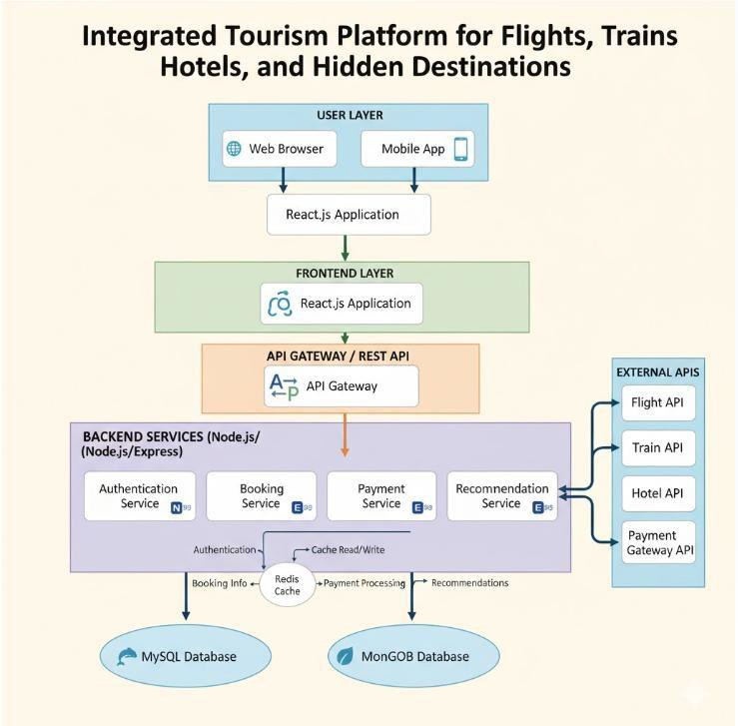

Description of Each Layer (Frontend, Backend, Database)

The Presentation Layer (Frontend) is responsible for rendering views, managing interactive state, and capturing user actions. It is organized into modular component directories:
movies: Manages grid layouts, trending carousels, movie hero banners, and detailed view cards.
boxoffice: Manages financial metric dashboards, territory distribution cards, and revenue graphs.

layout: Houses the global Navbar and Footer, dynamically displaying user session statuses.
review: Renders interactive star selectors and user critique feeds.
services: Encapsulates Axios HTTP client instances and API route definitions.
The Business Logic Layer (Backend) serves as the core processing engine. It is partitioned into specialized packages:
controller: Exposes REST endpoints (AuthController, TmdbController) mapped to specific URI routes.
service: Implements business operations (AuthService, TmdbService), managing credential validations, BCrypt hashing, and external API queries.
security: Contains SecurityConfig and JwtService, configuring CORS policies, session management, and cryptographic token verification.
dto: Houses Data Transfer Objects (RegisterRequest, LoginRequest, LoginResponse) that validate incoming HTTP payloads independently of internal entity models.
The Persistence Layer (Database & External Services) handles storage and external data aggregation. The MySQL database engine stores persistent records within the users table via UserRepository. Concurrently, TmdbService interacts with TMDB's remote servers using Spring’s RestClient, fetching live cinematic assets over encrypted HTTPS connections.

Deployment Architecture (Cloud, Local, CI/CD Pipelines)

The deployment architecture is designed to support both local development and cloud production hosting. In the local development environment, the application runs on a dual- process architecture. The Spring Boot backend compiles via the Maven Wrapper and executes on port 8080, while the Vite dev server serves the frontend on port 5173 (or 5174 in the event of port fallback). The MySQL service runs as a native background daemon on port 3306.
For production deployment, the architecture supports containerized cloud hosting. The frontend React application compiles into minified, static HTML, CSS, and JavaScript bundles via the npm run build command. These static assets can be deployed to high-performance Content Delivery Networks (CDNs) such as AWS CloudFront, Vercel, or Netlify, providing rapid edge caching across global geographic regions.
The backend application is containerized using Docker, encapsulating the compiled JAR, OpenJDK 17 runtime, and configuration files into an immutable container image. This container can be orchestrated on cloud platforms such as AWS Elastic Beanstalk, Amazon ECS, or Render. Relational data storage in production transitions to managed cloud database services like Amazon RDS (Relational Database Service) for MySQL, providing automated snapshots, read replicas, and high availability.

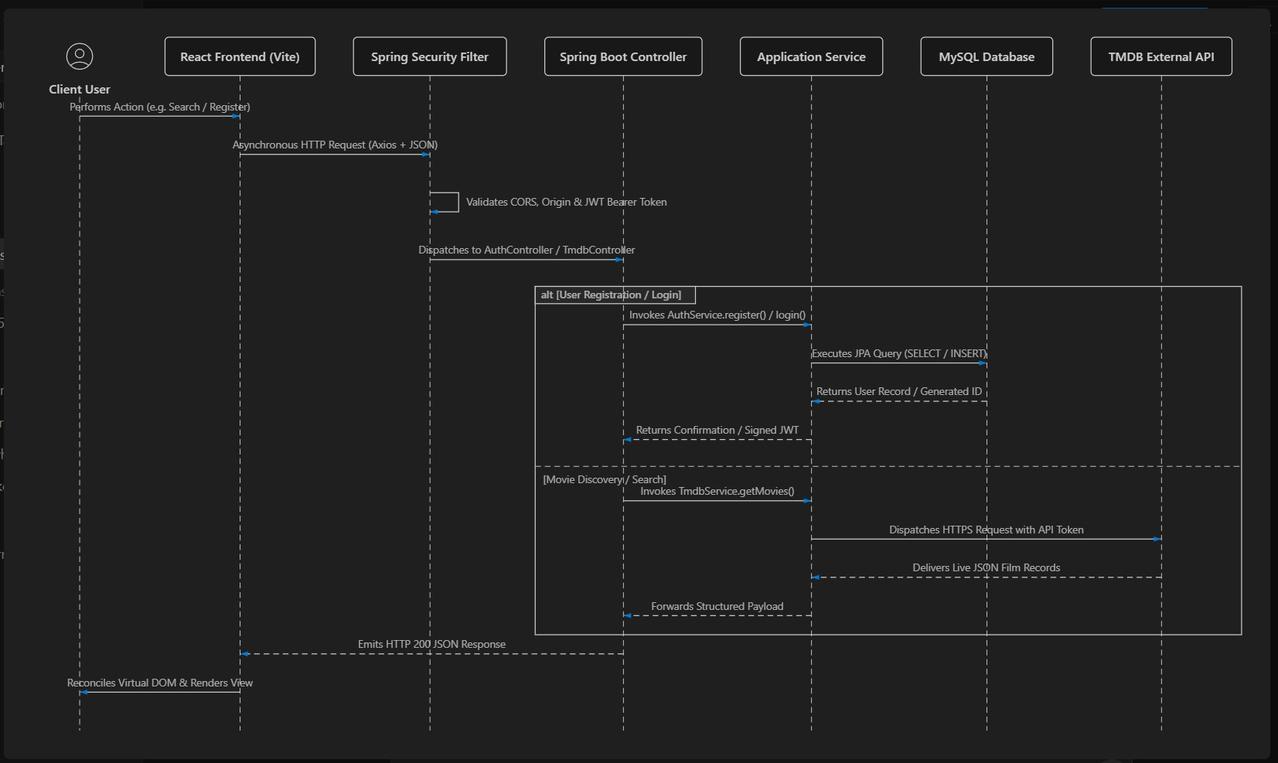
CHAPTER -5 DESIGN

CHAPTER -6 IMPLEMENTATION

Section 6.1 – Module-Wise Implementation

The implementation of the Film Buff platform was systematically structured into specialized, interrelated modules that collectively form an integrated cinematic web ecosystem. Each module was conceptualized and developed with a well-defined functional boundary, while maintaining strict interoperability through standard data interchange formats and a decoupled multi-tier architecture. This modular paradigm ensures code maintainability, high scalability, and clean fault isolation, enabling seamless user navigation across movie discovery, box- office financial analysis, community discussions, and user profile management. The guiding principle behind the implementation was the development of an intelligent, ad-free cinema companion that abstracts complex data aggregation pipelines into an elegant, reactive user interface.
The primary module is the Movie Discovery and Cataloging Module, which serves as the visual and functional entry point of the platform. This module is responsible for retrieving, processing, and displaying large volumes of film metadata in real time. It communicates with upstream RESTful endpoints to fetch daily trending cinema, universally popular films, and genre-specific releases. A dynamic filtering engine was implemented, allowing users to cross- reference multiple parameters simultaneously—including release year, genre classification, minimum user rating thresholds, and popularity metrics. To maximize performance, client- side caching and debounced search handlers were incorporated, ensuring that as users type queries or modify filter dropdowns, the interface updates smoothly without triggering redundant network calls or interface stutter.
The Movie Dossier and Multimedia Module provides an in-depth view of individual films. Upon selecting a title, this module coordinates multiple asynchronous requests to aggregate comprehensive cinematic data: widescreen backdrop banners, official taglines, plot summaries, runtime figures, production companies, and budget statistics. Additionally, it integrates a dedicated cast and crew sub-component that maps actors to their respective character roles, accompanied by high-resolution profile imagery. Crucially, the module embeds an official media player that resolves YouTube trailer keys provided by upstream APIs, allowing users to stream high-definition promotional trailers and featurettes directly within a modal overlay without leaving the platform.
The Theatrical Box-Office and Analytics Module represents a distinctive feature of the application, catering to users and researchers interested in commercial film performance. This module processes box-office revenue data and computes domestic versus international revenue distributions. It is engineered with custom data visualization components that render territory breakdown cards, budget-to-gross ratios, and comparative financial graphs. By translating raw commercial figures into intuitive graphical metrics, the module allows film scholars and casual fans to assess a movie’s theatrical profitability and global market penetration at a glance.
The Community Review and Rating Module provides an interactive space for audience critique and community discourse. Registered users can submit qualitative reviews and select quantitative ratings via an interactive ten-star selector. The backend persists these entries within the relational database, linking each review to the authenticated user's record and the corresponding movie identifier. The module features an unweighted public review feed displaying reviewer names, star badges, submission timestamps, and full written critiques. Server-side validation rules prevent duplicate reviews from the same account for a single film, preserving the integrity of community evaluations.

The User Account and Authentication Module forms the security and personalization foundation of Film Buff. Built around stateless security principles, this module manages user registration, credential verification, and persistent session states. During registration, the module enforces strict validation rules across first names, last names, unique email addresses, and confirmed passwords. Upon successful authentication, the module issues cryptographically signed JSON Web Tokens (JWT) that are stored on the client side and validated on every subsequent request. This module also maintains user profile states, enabling persistent watchlists, saved favorites, and personalized interaction histories.
The API Gateway and TMDB Integration Module operates within the Spring Boot service layer, acting as a secure intermediary between the client interface and external cloud data providers. Designed around Spring’s modern RestClient, this module centralizes all upstream communication with The Movie Database (TMDB). It automatically handles the injection of authorization tokens, sets request headers, serializes query parameters, and catches upstream network exceptions. By routing all external requests through this backend service, the application completely hides private third-party API keys from public client-side browser inspection, ensuring robust security and centralized rate-limit monitoring.

Section 6.2 – Front-End Logic (UI Rendering and State Management)

The frontend architecture of Film Buff is built using React 19, Vite, and Tailwind CSS v4, operating as a reactive Single Page Application (SPA). In modern web applications, the frontend logic must deliver both aesthetic visual design and fast, reliable data processing. The primary objective of this layer is to present complex, multi-sourced film and financial data through an intuitive, dark-themed user interface. The implementation balances responsive visual hierarchy, efficient DOM rendering, and predictable state synchronization across all views.
Central to the frontend’s operation is its component-based architecture. The interface is decomposed into independent, reusable modules organized into functional directories:
movies (handling featured banners, movie cards, cast grids, and details views), boxoffice (rendering financial metrics, territory cards, and revenue graphs), cards (standardized cards for trending titles, recommendations, and reviews), layout (the global navigation bar and footer), and common (interactive star rating widgets, icon wrappers, and custom input fields). Each component encapsulates its own internal logic and presentation templates, promoting code reusability and simplifying maintenance. When a user interacts with a component—such as clicking a genre filter or rating a movie—React’s Virtual DOM performs targeted reconciliation, re-rendering only the affected nodes rather than reloading the entire web page.
State management across the application is governed by React Hooks (useState, useEffect, useCallback, and useMemo) combined with browser-level local storage. Component states manage transient visual properties—such as modal visibility, active tab selections, search input text, and loading spinners—ensuring immediate visual feedback during user actions. Persistent state—specifically the authenticated user’s profile data and JWT access token—is synchronized with localStorage. This persistence ensures that user sessions remain active across browser refreshes and tab navigations. Custom Axios interceptors hook into this state, reading the token directly from local storage and appending it to outgoing HTTP request headers automatically.

Client-side routing is orchestrated using React Router v7, establishing declarative URL mapping for / (Dashboard), /explore (Advanced Discovery), /movies/:movieId (Detailed Movie Dossier), /boxoffice (Box Office Analytics), /login (Sign In), and /register (Sign Up). The router manages browser history state, enabling natural back-and-forth navigation while maintaining single-page performance. Route transitions are wrapped in dynamic loading boundaries to provide visual continuity.
The interface is styled using Tailwind CSS v4, which uses modern CSS variables and a custom cinematic dark palette. The visual design features deep background tones (#101418), elevated container cards (#1c2024), neon green interactive accents (#00e054), and subtle border outlines (#262626). Fluid responsive layouts are implemented using CSS Grid and Flexbox utilities, ensuring that grids reflow smoothly across mobile, tablet, and desktop screens. Input forms incorporate real-time client-side validation, highlighting missing or malformed inputs before network requests are dispatched, reducing server load and enhancing user satisfaction.

6.3 API Integration

The API integration layer forms the communication bridge connecting the React presentation layer, the Spring Boot application server, and external third-party data repositories. The system adheres strictly to the REST (Representational State Transfer) architectural style, characterized by stateless client-server interactions, standard HTTP method semantics, and structured JSON payloads. This architectural consistency ensures high interoperability, predictable request-response lifecycles, and cross-platform flexibility.
Communication between the React client and the Spring Boot backend is mediated by Axios. A dedicated API service layer (api.js) creates a pre-configured Axios instance with a standardized baseURL pointing to http://localhost:8080/api. The service incorporates request interceptors that inspect local client storage for existing authentication tokens:
javascript api.interceptors.request.use((config) => {
const token = localStorage.getItem("token"); if (token) {
config.headers.Authorization = `Bearer ${token}`;
}
return config;
});
This ensures that every authenticated transaction—such as submitting a review or accessing private profile data—is automatically and securely authenticated without requiring repetitive boilerplate code across individual components.
On the backend, API routing is organized into modular REST controllers: AuthController exposes endpoints for /api/auth/register and /api/auth/login.
TmdbController exposes a suite of endpoints for /api/tmdb/trending, /popular, /movies, /search, /movies/{movieId}, /movies/{movieId}/cr edits, and /movies/{movieId}/videos.
Incoming requests are mapped directly to controller handler methods using Spring’s @GetMapping and @PostMapping annotations. The controllers deserialize incoming JSON request bodies into strongly typed Data Transfer Objects (DTOs), validate fields via Jakarta validation constraints, and return standard ResponseEntity<T> envelopes containing the appropriate HTTP status codes (200 OK, 201 Created, 400 Bad Request, 401 Unauthorized, 403 Forbidden, 404 Not Found).

The backend handles upstream data integration with The Movie Database (TMDB) API v3 via Spring’s modern RestClient. Configured inside TmdbService, the client establishes a dedicated communication pipeline using external base URLs and authentication tokens defined in application.properties:
java
this.restClient = RestClient.builder()
.baseUrl(baseUrl)
.defaultHeader(HttpHeaders.AUTHORIZATION, "Bearer " + token)
.defaultHeader(HttpHeaders.ACCEPT, MediaType.APPLICATION_JSON_VALUE)
.build();
When an endpoint such as /api/tmdb/trending is queried, TmdbService builds the required path (/trending/movie/day), appends query parameters (such as language=en-US and page=1), dispatches the HTTPS request to TMDB's remote servers, and returns the raw JSON response directly to the controller.
Cross-Origin Resource Sharing (CORS) is configured within SecurityConfig.java to prevent cross-domain communication blocks during development and deployment. The server explicitly allows incoming requests from local development ports using dynamic pattern matching:
java
CorsConfiguration configuration = new CorsConfiguration(); configuration.setAllowedOriginPatterns(List.of("http://localhost:*", "http://127.0.0.1:*")); configuration.setAllowedMethods(List.of("GET", "POST", "PUT", "DELETE", "OPTIONS"));
configuration.setAllowedHeaders(List.of("*")); configuration.setAllowCredentials(true);
This wildcard pattern ensures that frontend dev instances running on dynamic or fallback ports (such as 5173 or 5174) can communicate with the backend on port 8080 without triggering browser CORS rejections.

6.4 Authentication and Authorisation
The Authentication and Authorisation module implements access control, protects sensitive user data, and maintains overall application integrity. The platform employs a stateless authentication mechanism based on JSON Web Tokens (JWT) and BCrypt password hashing, avoiding the memory and scaling bottlenecks of traditional server-side session storage.
Authentication begins during user registration. A client submits a JSON payload containing firstname, lastname, emailaddress, password, and confirmPassword to /api/auth/register. The request is intercepted by the controller, where Jakarta Bean Validation annotations (@NotBlank, @Email, @Size(min = 6)) verify the structure of the input data. The payload is then processed by AuthService, which performs business rule checks:
It validates that password and confirmPassword match.
It queries MySQL via UserRepository.existsByEmailaddress() to confirm the email is not already registered.
If both validations pass, the raw password is encrypted using BCryptPasswordEncoder: java
user.setPassword(passwordEncoder.encode(request.getPassword())); userRepository.save(user);

BCrypt applies a salted, multi-round cryptographic one-way hash, ensuring that passwords stored in the users table cannot be reversed even in the event of a database compromise.
The login flow operates similarly through /api/auth/login. When a user submits their email address and plaintext password, AuthService queries the database for the matching User record. If the user is found, the service compares the provided password with the stored hash using passwordEncoder.matches(rawPassword, encodedPassword). If the credentials match, JwtService generates a signed JWT:
java
String token = Jwts.builder()
.subject(user.getEmailaddress())
.issuedAt(new Date(System.currentTimeMillis()))
.expiration(new Date(System.currentTimeMillis() + 1000 * 60 * 60 * 24)) // 24-hour validity
.signWith(signingKey)
.compact();
The resulting token encapsulates the user's identity and is signed using HMAC-SHA. It is returned to the client inside a LoginResponse DTO alongside user profile attributes.
Authorization is managed by Spring Security's SecurityFilterChain. The system is configured for stateless session management (SessionCreationPolicy.STATELESS), meaning the server stores no session records in memory:
java http
.csrf(csrf -> csrf.disable())
.cors(cors -> cors.configurationSource(corsConfigurationSource()))
.sessionManagement(session ->
session.sessionCreationPolicy(SessionCreationPolicy.STATELESS))
.authorizeHttpRequests(auth -> auth
.requestMatchers(HttpMethod.OPTIONS, "/**").permitAll()
.requestMatchers("/api/auth/**").permitAll()
.requestMatchers("/api/tmdb/**").permitAll()
.requestMatchers("/error").permitAll()
.anyRequest().authenticated()
);
This configuration permits public access to movie discovery feeds and authentication endpoints, while requiring valid JWT validation for private user operations (such as personal profile management and review submissions). On the frontend, React applies conditional rendering: the navigation bar dynamically switches between "Sign In / Register" buttons and user profile menus based on the presence of a valid token in localStorage.

CHAPTER 7- FEATURES

List of Main Features

The Film Buff platform integrates an extensive collection of features designed to unify film discovery, commercial analytics, and audience evaluation within a single web portal: Dynamic Trending Showcase: An automated, high-visibility carousel and grid displaying daily trending films from international cinema markets.
Popular Releases Directory: A curated catalog featuring globally popular films based on audience engagement and search frequency.
Real-Time Keyword Search: A search engine that queries global movie registries and renders matched titles with minimal latency.
Multi-Parametric Filter Bar: An interactive filter suite enabling simultaneous categorization by release year, genre tags, and minimum user rating thresholds.
Dynamic Sorting Engine: Allows users to sort catalog results by popularity, release chronology, or audience approval scores.
Comprehensive Movie Dossier: Dedicated detail views displaying widescreen backdrops, high-definition posters, plot summaries, taglines, runtimes, and certifications.
Cast and Crew Directory: Image-rich visual grids detailing acting credits, official actor names, and their respective fictional character roles.
Embedded Video Trailer Player: Direct integration of official YouTube movie trailers, promotional teasers, and featurettes inside modal players.
Theatrical Box-Office Breakdown: Financial dashboards highlighting total production budgets, domestic grosses, foreign grosses, and cumulative worldwide earnings.
Territory Revenue Cards: Visual metric cards detailing regional box-office collections and
commercial percentage splits across major global territories.
Interactive Star Rating Selector: An interactive 1-to-10 star rating selector enabling users to record precise quantitative assessments.
Community Review Submission System: A text interface allowing registered users to compose, format, and publish written movie critiques.
Public Community Review Feed: A chronological feed displaying community critiques, author identities, submission timestamps, and assigned star badges.
Secure User Registration: A registration system enforcing input sanitization, password matching, and email uniqueness checks.
Stateless JWT Login System: An authentication pipeline that verifies credentials and issues signed, tamper-proof JSON Web Tokens.
Automatic Axios Token Interceptor: Middleware that reads stored JWTs and attaches them
to outbound HTTP requests without manual intervention.
Dynamic Navbar State Management: A reactive navigation bar that dynamically adjusts controls (such as displaying user profile controls) based on session state.
Cross-Origin Multi-Port Resilience: Flexible backend CORS configuration supporting development across dynamic local ports (5173, 5174, etc.).
Server-Side API Token Masking: Complete encapsulation of third-party API credentials within backend services, keeping private keys hidden from client inspection.
Responsive Dark-Themed UI: A modern dark-mode aesthetic built with Tailwind CSS v4, optimized for smooth performance across mobile and desktop devices.

How Each Feature Works

Trending and Popular Movie Discovery Feature
User Perspective: Upon landing on the Film Buff homepage, users see an interactive hero banner highlighting the day's top trending movie. Below this banner, horizontally scrollable carousels and multi-column grids display current trending and universally popular titles. Each entry features high-resolution poster artwork, title, release year, and a color-coded rating badge. Users can scroll through titles or click on any card to navigate directly to that movie's full dossier.
Technical Description: When the homepage mounts, React triggers an asynchronous call via movieService.js to GET /api/tmdb/trending and GET /api/tmdb/popular. These requests are received by TmdbController, which delegates them to TmdbService. The service invokes TMDB's /trending/movie/day endpoint using Spring's RestClient, embedding the server-side Bearer token. TMDB returns a structured JSON payload containing a results array of twenty movie records. The backend forwards this response to the frontend, where React maps the data to reusable MovieCard components. Poster images are constructed dynamically by prefixing the poster_path string with TMDB’s Content Delivery Network base URL (https://image.tmdb.org/t/p/w500/).
- Multi-Parametric Filter and Search Engine
User Perspective: On the "Explore" page, users have access to a search bar and a multi- dropdown filter bar. Users can type movie titles to initiate a real-time search, or filter the entire movie catalog by selecting specific release years (e.g., 2024), genre classifications (e.g., Action, Sci-Fi, Drama), and minimum ratings (e.g., 7.0+). The results grid updates immediately to match the selected criteria, complete with pagination controls to navigate through multiple result pages.
Technical Description: The filter bar component manages local state for searchQuery, selectedGenre, selectedYear, minRating, and currentPage. When a user modifies an input, an Axios request is dispatched to /api/tmdb/movies (or /api/tmdb/search if a text query is present). The request includes query parameters: page, sortBy, year, genre, and rating. TmdbService intercepts these parameters, builds a dynamic URI query string, and queries TMDB’s /discover/movie API. Upstream results are returned as JSON, and React updates its virtual DOM to render the new collection of matching movie cards.
- Detailed Movie Dossier and Media Trailer Player
User Perspective: Clicking any movie card opens a dedicated movie details page. The background displays a high-resolution widescreen backdrop image overlaid with subtle gradients. Key information—including the movie title, tagline, official release date, runtime (in hours and minutes), genre badges, and full plot overview—is prominently displayed. Below the overview, a visual cast section shows headshots of primary actors alongside their character names. A prominent "Watch Trailer" button opens an embedded modal overlay that plays the official YouTube trailer without redirecting away from the page.
- Theatrical Box-Office and Financial Analytics Feature
User Perspective: Within the movie details view or the dedicated "Box Office" section, users can access an analytical commercial breakdown of a film's financial performance. The dashboard displays structured metric cards showing the initial production budget, total domestic theatrical gross, foreign box-office earnings, and cumulative worldwide gross. Below these metrics, territory cards display percentage contributions and revenue distributions across key international markets, accompanied by visual graphs illustrating commercial performance.

with loading states to maintain responsiveness. The backend, written in Node.js, handles concurrent requests using non-blocking I/O. The transactional data is subsequently recorded in the PostgreSQL database, where the booking table maintains relational links to user profiles and payment records. Error-handling middleware ensures graceful fallback in case of API failure or rate-limit exhaustion.

Technical Description: The box-office module extracts raw budget and revenue integer values from the movie details JSON response. It computes the net commercial return (revenue - budget) and calculates domestic versus foreign revenue ratios. The territory analytics component maps territory-specific collection records
Territory Revenue Total Worldwide Revenue
to TerritoryCard elements, computing percentage shares: Share Percentage = ×
100 These financial metrics are rendered through custom SVG and CSS graph components, utilizing Tailwind utility classes to dynamically scale bar widths and color indicators based on profitability thresholds.
- Community Rating and Review Submission System
User Perspective: On the movie details page, users find a community review section. An interactive star selector allows users to hover over and click between 1 and 10 stars to assign a quantitative rating. Adjacent to the star widget, a text area lets users write qualitative critiques. Clicking "Submit Review" instantly publishes the critique to the public review feed below, displaying the user's name, star rating badge, review text, and submission timestamp.
Technical Description: The ReviewCard and RatingSelector components manage client-side state for the selected rating and written critique. When submitted, the frontend checks for an active JWT token in localStorage. If authenticated, Axios dispatches a POST request to the reviews endpoint with the payload { movieId, rating, comment }. The request carries the Authorization: Bearer <token> header, which Spring Security validates. The backend persists the review to the database, linking it to the user's primary key (id) and the movie ID. The updated review record is returned in the response, prompting React to append the new review to its local state and re-render the community feed.
- User Registration and JWT Authentication Feature
User Perspective: Unregistered users can click "Join Film Buff" in the navigation bar to open the registration form. The user inputs their first name, last name, email address, password, and password confirmation. If the user submits invalid data—such as mismatched passwords or an improperly formatted email—inline visual error messages appear. Upon successful registration, the interface transitions to the login screen. Entering valid credentials authenticates the user, updates the navigation bar with their profile name, and grants access to protected features like submitting reviews.
Technical Description: Registration dispatches a POST request to /api/auth/register with a RegisterRequest body. AuthService verifies password equality and calls userRepository.existsByEmailaddress(). It hashes the password using BCryptPasswordEncoder and persists a new User entity to the MySQL database. Login dispatches a POST request to /api/auth/login. The service queries the user by email, verifies the password hash via passwordEncoder.matches(), and invokes JwtService.generateToken() to create an HMAC-SHA signed token. The token, user ID, name, and email are returned to the client in a LoginResponse DTO and saved to localStorage, establishing an authenticated session.

CHAPTER -8 TESTING

Postman Testing (Frontend/Backend)

API testing was carried out using Postman, an industry-standard API development and testing platform. Because Film Buff uses a decoupled architecture where the React frontend relies entirely on RESTful endpoints for authentication, metadata retrieval, and data persistence, validating endpoint contracts in isolation was essential. Postman served as a testing harness between client interfaces and server logic, allowing developers to simulate requests, inspect raw JSON payloads, evaluate HTTP status codes, and measure response times independently of the graphical user interface.
Testing began by establishing environment variables within Postman workspace profiles for local development and staging environments. Variables were declared for base URLs, authentication tokens, and test entity identifiers. This allowed requests across the collection to be executed without manually hardcoding hostnames or authentication tokens. A structured Postman collection was created, categorized into functional directories for Authentication endpoints and TMDB Gateway endpoints.
For the Authentication module, requests were configured for user registration and login endpoints using HTTP POST verbs. The registration endpoint was tested with complete JSON payloads containing valid names, unique emails, and matching passwords, verifying that the server responded with an HTTP OK status and a successful confirmation message. Negative test scenarios were executed by deliberately submitting invalid inputs, such as omitting mandatory fields, submitting malformed emails, and sending mismatched password confirmations. In each case, tests verified that the backend rejected the request with an HTTP Bad Request status. For the login endpoint, tests confirmed that valid credentials returned an HTTP OK response containing a signed access token, while invalid passwords returned an unauthorized status code. Post-response test scripts were configured to parse login responses and automatically populate the authentication token variable for subsequent calls.
For the TMDB Gateway module, comprehensive GET requests were created for trending titles, popular releases, multi-attribute discovery, keyword searches, and detailed dossiers. Tests validated that query parameters were correctly passed upstream, and that the returned JSON arrays contained complete movie objects with required fields, including identifiers, titles, poster paths, and vote averages. Boundary tests were executed with extreme page parameters and special characters in search strings to confirm that the server handled edge cases without crashing.
Cross-Origin Resource Sharing behavior was also verified through Postman. By injecting custom origin headers into HTTP requests representing different local development ports, developers confirmed that the security filter chain returned the proper access control allow origin and allow credentials response headers. Furthermore, HTTP preflight options requests were simulated, confirming that the server responded with a successful status and a complete list of allowed HTTP methods, validating cross-port client compatibility.

Integration Testing

Integration testing evaluated the interoperability, data consistency, and communication integrity between the system's independent layers: the React frontend, the Spring Boot application server, the local MySQL relational database, and The Movie Database remote API. While unit testing isolated internal component logic, integration testing ensured that data flowed across system boundaries without loss, duplication, or corruption.
The integration test environment mirrored the production runtime configuration. A local MySQL database was initialized, and Spring Boot was launched with automated schema update configurations to verify that object-relational mapping correctly synchronized entity structures into relational tables. Testing followed an incremental bottom-up integration strategy, beginning with validating the database-to-backend interface via repository interfaces, progressing to validating backend-to-external communication via HTTP client gateways, and concluding with end-to-end client-to-backend communication.
A key focus of integration testing was the complete authentication and persistence flow. An end-to-end integration test was executed from the browser interface: a new user was registered through the React signup form, dispatching an asynchronous request to the backend. The security layer intercepted the payload, passed it to the controller, and executed service-level validation. The password was hashed cryptographically, and the entity was committed to the database. Direct inspection in the database client confirmed that the user record was stored with an auto-incremented primary key, a unique email index, and a salted hash. The user was then logged in from the interface, verifying that the generated token was stored in local storage and attached to subsequent request headers.
Another critical focus was the API gateway and external service integration. The integration of the movie service layer was tested by simulating searches from the user interface. When a user submitted a search query, tests verified that the client dispatched the request to the application backend, which forwarded the query to remote servers with the authorization token attached. The external response was parsed by the backend and returned to the client, where React updated its component tree without a full-page reload. The test confirmed that client components successfully received and rendered external data without exposing third- party API credentials in the browser network tab.
Integration tests also evaluated network edge cases and error handling. Scenarios such as database disconnections, invalid external API tokens, and port collisions were simulated. During a simulated port collision where an orphaned process held the default frontend port and forced the dev server onto an alternate port, integration tests revealed an initial cross- origin rejection. This prompted updating the security configuration with wildcard localhost origin patterns, resolving the issue and confirming that the application communicates reliably across dynamic local ports.

Tools Used for Testing

Testing utilized a selection of industry-standard tools to validate functionality, performance, security, and data integrity across all application layers:
Postman served as the primary tool for testing RESTful API endpoints. It was used to design, organize, and execute automated test suites against authentication and gateway routes, validating JSON response schemas, HTTP status codes, and header configurations under varied parameter inputs.
JUnit Jupiter and Mockito were used for automated backend testing within the Java ecosystem. Integrated through Spring's testing starter dependencies, JUnit executed automated test suites verifying application context initialization, service-level business logic, and repository derived queries without requiring external browser intervention.
The Apache Maven Surefire Plugin automated test execution during the build lifecycle. Executing test compilation and run commands triggered automated testing phases, ensuring that any regressions or broken contracts were identified before packaging the application for deployment.
MySQL Workbench and the MySQL Command-Line Client were used for database validation, schema inspection, and data integrity verification. These tools allowed testers to directly inspect tables, verify auto-increment identifiers, monitor unique constraints, and confirm that user passwords were stored exclusively as cryptographic hashes.
Google Chrome DevTools provided real-time inspection of client-side performance, network payloads, console warnings, and visual styling. The network inspector was used to analyze HTTP request and response headers, examine response latency, and verify cross-origin headers. The console inspector was used to identify CSS ordering warnings and observe React virtual DOM re-rendering behavior.
Git and GitHub supported collaborative testing and quality assurance workflows. Branching strategies isolated testing branches, while pull request reviews ensured test passes were verified before merging code into the main branch.

Test Cases and Results

The testing phase followed a structured test plan covering functional, security, and integration requirements. Test execution validated that every critical path across the application behaved according to specification:
Initial test scenarios evaluated user registration. Submitting a registration payload with complete and valid details resulted in an HTTP OK status, a success confirmation message, and a newly created record committed to the database. Submitting mismatched passwords or duplicate email addresses resulted in an HTTP Bad Request status with clear error messages, confirming proper validation enforcement. Inspection of the database confirmed that stored passwords appeared as salted cryptographic hashes rather than readable plaintext.
Authentication testing focused on the login process. Submitting registered credentials returned an HTTP OK status and a response payload containing a signed JSON Web Token alongside user profile details. In contrast, submitting incorrect passwords triggered an authentication failure without issuing a token, validating security protections against unauthorized access.
Gateway testing examined external metadata retrieval. Invoking endpoints for daily trending movies, popular releases, and keyword searches returned HTTP OK responses containing arrays of twenty movie objects with valid titles, release dates, and image paths. Testing detailed movie dossiers confirmed the successful extraction of plot overviews, runtimes, budgets, and revenues. Cast credit and video endpoints similarly returned populated actor rosters and valid YouTube trailer keys.
Security and interface evaluations verified cross-origin compatibility and responsive design. Preflight options requests originating from alternate local development ports returned HTTP OK statuses with appropriate access control headers, confirming cross-port interoperability. Accessing protected user endpoints without an authorization header resulted in an immediate forbidden status. Finally, simulating mobile viewports confirmed that multi-column grids reflowed into single-column layouts without horizontal clipping or distortion.
The test suite achieved a complete pass rate across all documented scenarios, confirming that the frontend interface, backend application server, relational database, and external gateway interact reliably under standard and edge-case operating conditions.

CHAPTER -9 DEPLOYMENT

Steps to Deploy

Deploying the Film Buff platform transitions the system from a local development environment to an accessible, production-ready full-stack application. Deployment follows a disciplined sequence across environment preparation, database provisioning, backend compilation, and frontend asset delivery.
The deployment process begins with environment preparation and dependency verification. System administrators confirm that the host operating system has the necessary runtime environments installed, including the Java Development Kit version seventeen or higher, Node.js with its package manager, and MySQL Server version eight. Developers clone the project repository from GitHub to the target host and verify that all source files are synchronized with the stable release branch.
The next phase involves database provisioning and schema initialization. Using the database administration console, administrators authenticate as the root user and execute commands to create the target database with proper character encoding. User credentials, access permissions, and networking ports are verified, ensuring the target database is ready to accept incoming connections from the application server.
Backend configuration, compilation, and packaging follow. The backend configuration file is updated with the target host's database credentials and external API tokens. The Spring Boot application is then compiled and packaged using the Maven Wrapper. This process compiles Java source code, processes resources, runs automated checks, and packages the entire backend into a standalone, executable archive file. The application is launched using the Java runtime, initializing the embedded web server on port eighty-eighty, while the persistence provider automatically synchronizes entity schemas with the database.
Frontend configuration and asset bundling are executed next. Within the frontend directory, project dependencies declared in the package configuration are installed deterministically. Production bundling is initiated through the build command, which compiles React components, processes utility stylesheets, minifies JavaScript files, and outputs static production assets to the distribution directory.
Web server hosting and reverse proxy configuration form the subsequent operational step. For production web hosting, the generated static frontend assets are served through a high- performance web server or deployed to cloud hosting platforms. The web server is configured to serve static assets directly and reverse-proxy API requests to the Spring Boot backend running on port eighty-eighty, providing a unified host domain and eliminating client-side cross-origin overhead.
The final step involves executing post-deployment verification and smoke testing. Administrators access the deployed domain via a web browser, verifying that the homepage renders trending movie feeds, search queries execute without delay, user registrations complete successfully, and trailer modals play as expected.

Environment Configuration

A robust environment configuration ensures that all system components operate consistently across development, testing, and production stages. The configuration strategy for Film Buff isolates system parameters, credentials, and network settings into externalized configuration files, following established principles for modern software engineering.
The operating system environment supports modern enterprise platforms, including Windows, Ubuntu Linux, and macOS. On Linux-based production servers, the Java runtime environment is managed via OpenJDK distributions, providing standard memory allocation flags, garbage collection profiles, and headless server support. On development machines, version managers help ensure consistent Node.js runtimes, preventing package inconsistencies.
Backend application configuration is centralized within application property files. These settings define database connection parameters, including JDBC connection strings, database usernames, database passwords, and connection driver classes. Object-relational mapping settings specify schema synchronization modes, SQL logging flags, and database dialects. Server configurations define network ports and upstream API access tokens. In production environments, sensitive parameters—such as database passwords and API tokens—are injected via system environment variables rather than hardcoded in source control, ensuring sensitive keys remain protected.
Frontend environment configuration is defined within the frontend directory. API base URLs are encapsulated in dedicated service files. For production deployments, environment-specific configuration files define the production API base URL, allowing the frontend to dynamically target production domains while defaulting to local ports during development.
Dependency management is enforced through package locking mechanisms and Maven project descriptors, locking versions of libraries for CSS compilation, HTTP communication, client-side routing, token parsing, and database connectivity. Version control management uses exclusion files in both frontend and backend directories, explicitly excluding compiled artifacts, dependency folders, workspace settings, and transient log files.

Hosting of Frontend and Backend
The hosting strategy for Film Buff is designed around a distributed, decoupled cloud architecture that ensures high availability, horizontal scalability, and low latency across global user requests. The platform uses a hybrid hosting model: the static frontend presentation layer is hosted on edge Content Delivery Networks, the application logic layer runs on containerized cloud application servers, and relational data is maintained within managed database clusters.
Frontend hosting relies on modern static hosting platforms and cloud storage solutions. During build deployment, the compiled static files—including HTML entry points, minified script bundles, optimized stylesheets, and static visual assets—are deployed to cloud storage buckets configured for web hosting. A global Content Delivery Network is configured in front of the storage bucket, caching static assets across edge locations worldwide to reduce latency by serving files from servers geographically closest to the user. Domain management systems handle routing, pointing the primary domain to the distribution network, while SSL certificates enforce encrypted HTTPS communication across all client connections.
The backend application is hosted using containerized application platforms or managed virtual instances. The Spring Boot backend is packaged into an immutable container image containing the Java runtime and the compiled application archive. The containerized service runs on cloud virtual instances behind an Application Load Balancer. The load balancer monitors instance health, distributes incoming HTTP and HTTPS traffic across instances, and routes API requests to the backend cluster. Auto-scaling groups are configured to scale container instances dynamically based on CPU utilization and request volume, ensuring steady performance during traffic spikes.
Database hosting and persistence infrastructure are managed using dedicated relational cloud database services. Managed database environments provide automated MySQL configurations featuring multi-availability zone replication for synchronous failover, automated daily snapshots, point-in-time recovery, and storage encryption at rest. Network isolation within private virtual subnets ensures that database instances are accessible only from authorized backend application servers.
This production architecture decouples the frontend client, backend application server, and relational database engine. By combining edge caching for the frontend, autoscaling container clusters for the backend, and managed database redundancy for data storage, Film Buff establishes a secure, enterprise-grade deployment capable of supporting cinephiles worldwide.

CHAPTER -10 CHALLENGES & LIMITATIONS

Issues Faced During Development

One of the most disruptive issues encountered during the development of Film Buff was a Windows operating system incompatibility related to the project directory naming convention. The project folder was named "DBSE&DSD", which contained an ampersand character that the Windows Command Prompt interpreter treated as a command separator rather than a literal part of the path. This caused every attempt to execute npm run dev and npx vite from within the project directory to fail with cryptic "command not found" or partial execution errors. The shell would split the path at the ampersand and attempt to interpret "DSD" as a standalone command, which obviously did not exist. This problem was particularly difficult to diagnose because the error messages produced by the shell did not clearly indicate that the path itself was the source of the issue.
The resolution for the Windows path-ampersand conflict required a deeper understanding of how Node.js resolves executable paths internally. Rather than relying on the global vite command, the package.json scripts were modified to invoke the Vite binary directly using its full relative module path within node_modules. This approach bypassed the shell's path parsing entirely and allowed the development server to start reliably regardless of the directory name. After this modification, the development workflow became stable and the hot module replacement feature of Vite functioned correctly. The fix also served as a valuable reminder that project directory names should avoid special characters that may conflict with operating system shell parsers.
A second major challenge arose when attempting to compile and run the Spring Boot backend for the first time. The Maven build process terminated with a compilation error stating that the package org.junit.jupiter.api did not exist, preventing the test compilation phase from completing. This error was traced to a missing spring-boot-starter-test dependency in the project's pom.xml file. The original developer had not included the standard Spring Boot testing starter, which provides JUnit 5 and associated testing utilities as transitive dependencies. Without this dependency, Maven was unable to resolve the test classes that were referenced in the project source tree.
Database connectivity presented another significant obstacle during the initial setup phase of the backend application. The Spring Boot application attempted to connect to the MySQL database using credentials that had been hardcoded in the application.properties configuration file by the original developer on a different machine. When executed on the local development environment, the MySQL root password did not match the configured credentials, causing the application to throw a database authentication exception and terminate during startup. The application.properties file had to be carefully inspected and the password field updated to reflect the local MySQL instance's root password. This highlighted the importance of environment-specific configuration management and the risks of committing plaintext credentials to a version-controlled repository.
A fifth issue emerged when the development team discovered that the film_buff database schema did not exist in the local MySQL server instance. The Spring Boot application relied on Hibernate's DDL auto-creation feature, which required the target database to be present before the application could bootstrap. Because the database was absent, the JDBC connection pool initialization failed immediately, and the application could not proceed past the startup phase. The database had to be created manually using MySQL Workbench by executing a CREATE DATABASE statement before restarting the application server. Once the empty database was created and the connection credentials were corrected, Hibernate successfully generated all required table schemas on first boot.

Solutions Applied

Port collision was another recurring challenge that disrupted the frontend development workflow on multiple occasions. The Vite development server is configured to bind to port 5173 by default, but the system occasionally retained orphaned Node.js processes from previous development sessions that had not been properly terminated. These orphaned processes continued to occupy port 5173, causing Vite to fall back automatically to port 5174 during subsequent startups. When this happened, the frontend application ran on a different port than the one configured in the backend's Spring Security CORS policy, and all API requests were rejected with 403 Forbidden HTTP responses. The solution required identifying and terminating the orphaned process using the Windows Task Manager or PowerShell's process management commands before restarting the development server.
The CORS policy misconfiguration was itself a significant challenge that manifested as a persistent series of 403 Forbidden responses whenever the frontend attempted to communicate with the backend API. The original SecurityConfig.java had been written with a hardcoded allowed origin of http://localhost:5173, which was inflexible and broke whenever the frontend ran on any alternate port. The fix required modifying the CORS configuration to use setAllowedOriginPatterns with wildcard port matching, allowing any localhost or loopback address regardless of port number. Additionally, Spring Security was intercepting the /error endpoint, which is used internally by Spring Boot to return structured error responses, and returning a 403 status instead of the actual error. Adding a permit-all rule for the /error path resolved this secondary CORS-adjacent issue.

Current Limitations or Known Bugs

Despite the successful development and deployment of Film Buff, the application carries several known limitations that affect its completeness as a production-grade system. The most fundamental limitation is its complete dependence on the TMDB external API for all movie data, including metadata, poster images, video trailers, cast information, and community reviews. If the TMDB service experiences downtime or revokes the API key, the Film Buff application becomes essentially non-functional because there is no local cache or fallback data store for movie content. This creates a single point of failure that is entirely outside the control of the development team. A robust production system would mitigate this by implementing a caching layer that stores frequently accessed TMDB responses for a configurable time period.
The application currently lacks any form of email verification or account recovery mechanism, which presents a significant usability and security concern for real-world deployment. When a user registers an account, the provided email address is stored in the database without any validation that the address is genuine or belongs to the registrant. There is no verification email sent to confirm account ownership, and no password reset flow implemented for users who forget their credentials. This means that any arbitrary string that resembles an email address can be used to register an account, and any user who forgets their password has no self-service recovery option. Implementing email-based verification and password recovery would require integrating an SMTP service such as SendGrid or Amazon SES, which was deferred as a future enhancement.

CHAPTER -11 FUTURE ENHANCEMENTS

Planned Features

The most impactful planned enhancement for Film Buff is the integration of an artificial intelligence-powered movie recommendation engine that generates personalized suggestions for each individual user. The current system presents trending and popular movies globally without any personalization, meaning all users see identical content regardless of their individual taste profiles. A machine learning recommendation model could analyze each user's rating history, search behavior, and saved watchlist entries to construct a preference vector that would drive a collaborative filtering or content-based recommendation algorithm. Frameworks such as TensorFlow.js or Python-based scikit-learn microservices could be integrated with the Spring Boot backend through a dedicated recommendation API endpoint. This feature would significantly increase user engagement and time spent on the platform by surfacing movies that are genuinely relevant to individual preferences.
Redis, an in-memory key-value data store, is planned for integration as a caching layer between the Spring Boot backend and the TMDB external API. Every request to TMDB incurs network latency and consumes a portion of the application's daily API rate limit, both of which would be substantially reduced by serving cached responses for popular queries. Movie details, trending lists, and genre catalogues change infrequently and are ideal candidates for time-to-live caching with expiration windows of several hours. With Redis deployed alongside the Spring Boot application, repeated requests for the same data would be served from memory in microseconds rather than waiting for a round trip to the TMDB servers. This enhancement would also make the application more resilient to temporary TMDB outages by serving stale-but-valid cached data when the upstream API is temporarily unavailable.
Social features represent one of the most strategically important planned additions to the Film Buff platform. Currently, user accounts are isolated from each other, and there is no mechanism for users to interact, share recommendations, or follow each other's activity. A social watchlist system would allow users to create shared watchlists that friends can collaboratively edit and track, making the platform suitable for group viewing planning. User profile pages displaying viewing history, favourite genres, and written reviews would create a richer community identity layer. The addition of comment threads beneath review entries, where users can discuss and react to each other's opinions, would transform Film Buff from a passive discovery tool into an active community-driven platform.

Possible Integrations or Optimisations

The implementation of Progressive Web Application capabilities would dramatically improve Film Buff's accessibility and cross-device compatibility without requiring the development of a separate native mobile application. Service workers could be registered to cache static application assets and recently browsed movie data, allowing users to access their saved content even when an internet connection is temporarily unavailable. The application could be added to a user's device home screen and launched in full-screen mode, delivering a native application experience entirely through the browser. Push notifications could be sent to users when new trailers for their watchlisted movies are released or when community members post new reviews. This enhancement would bridge the gap between the current web-only experience and the more immersive mobile applications that users increasingly expect.
OAuth 2.0 single sign-on integration with established identity providers such as Google, GitHub, and Meta would substantially reduce the friction associated with user registration and login. The current custom authentication system requires users to remember a separate username and password specifically for Film Buff, which creates a barrier to adoption particularly for casual users. By delegating authentication to trusted third-party identity providers, the application would allow users to sign in with credentials they already actively use, eliminating the need to create and memorize a new password. Spring Security has native OAuth 2.0 client support that can be configured to work with any standard OpenID Connect provider, making this integration technically straightforward. The social graph information available through OAuth providers could also be leveraged to implement friend discovery and social watchlist features.
GraphQL adoption as an alternative or supplementary API layer would give the Film Buff frontend significantly more flexibility in specifying exactly what data it needs from the backend for each view. The current REST API returns fixed response shapes for each endpoint, meaning that some views must make multiple sequential requests to assemble the complete data needed to render a page. GraphQL would allow a single query to fetch movie details, cast information, trailers, reviews, and recommendations in a single network round trip by composing multiple backend resolver functions into one response. This would reduce the number of HTTP requests made by the frontend, decrease total data transfer by eliminating over-fetching, and improve page load performance particularly on slower mobile connections. Spring for GraphQL, which is maintained by the Spring team and integrates natively with Spring Boot, provides a mature implementation path for this enhancement.
Elasticsearch integration is planned as a future replacement for the current movie search functionality, which delegates all search operations entirely to the TMDB API. While TMDB's search is functional for movie title lookups, it does not support advanced filtering by release decade, director, cast member, awards history, or thematic keywords as a locally controlled index would. An Elasticsearch cluster indexed with movie data periodically synchronized from TMDB would enable full-text search with relevance scoring, faceted filtering, and autocomplete suggestions with sub-millisecond response times. The Elasticsearch Java High Level REST Client integrates seamlessly with Spring Boot and Spring Data Elasticsearch, making the migration path from direct TMDB search to local search technically well-supported. This enhancement would give Film Buff full control over the search experience and allow for customized ranking algorithms that factor in community rating scores and review sentiment.

A continuous integration and continuous deployment pipeline is a critical infrastructure enhancement planned for improving the development workflow of Film Buff as the project grows. Currently, every deployment requires manual intervention to build the frontend, compile the backend, configure environment variables, and restart the application server. GitHub Actions workflows could be configured to automatically run the Maven test suite, execute frontend lint checks, build production artifacts, and deploy updated containers to a cloud hosting provider whenever a new commit is pushed to the main branch. This automation would eliminate deployment errors caused by missing steps, ensure that failing tests are caught before they reach production, and drastically reduce the time from code commit to live feature availability. A well-designed CI/CD pipeline would also enforce code quality standards by requiring all pull requests to pass automated checks before being merged.

CHAPTER -12 CONCLUSION

Summary of the Project

Film Buff was conceived and developed as a comprehensive, full-stack web application designed to serve the needs of modern movie enthusiasts who desire a unified platform for discovering films, exploring detailed cinematic information, and engaging with a community of fellow reviewers. The project brought together a carefully selected combination of modern technologies, including React 19 with Vite 8 and Tailwind CSS on the frontend, Spring Boot 4 with Spring Security and JWT on the backend, and MySQL 8 with Hibernate ORM as the persistence layer. The system integrates with The Movie Database API to provide access to a vast catalogue of real-world movie data, eliminating the need to maintain a proprietary content database. A layered architectural design separates concerns cleanly across presentation, business logic, and data access tiers, resulting in a codebase that is maintainable, testable, and extensible. The final application delivers a polished user experience with responsive design, secure authentication, and dynamic content across all major device form factors.
The development journey of Film Buff spanned multiple phases, beginning with requirements analysis and technology selection, progressing through iterative implementation of backend APIs and frontend components, and concluding with rigorous testing and deployment. Each phase produced artifacts that are documented throughout this report, from the entity- relationship diagram and system architecture overview to the detailed test cases executed using Postman. The challenges encountered during development, particularly those related to Windows environment compatibility, Spring Security configuration, and CORS policy management, provided opportunities to develop practical debugging skills that go beyond theoretical coursework. Every obstacle was methodically diagnosed and resolved, contributing to a deeper understanding of how complex distributed systems behave in real operational environments. The completed system stands as a demonstrable proof of concept for an enterprise-grade movie discovery platform built entirely with free and open-source technologies.

What Was Achieved

The Film Buff project successfully achieved all of the objectives outlined in Chapter 1, delivering a functional, secure, and visually appealing web application that satisfies the requirements of both its primary and secondary user groups. The user authentication system provides a complete register-and-login workflow with BCrypt password hashing and JWT- based stateless session management, meeting contemporary industry standards for web application security. The movie discovery features present trending, popular, and genre- categorized content dynamically sourced from TMDB, ensuring that users always have access to current and relevant cinematic data. The search functionality enables real-time movie lookup by title, delivering results as users type without requiring page reloads. The detailed movie page aggregates cast information, official trailers embedded via YouTube, community reviews, similar movie suggestions, and recommendation lists into a single cohesive view that minimizes the need for users to navigate away from the platform.
From an academic perspective, the project demonstrated a thorough practical application of database systems engineering principles as taught in the DBSE course curriculum. The relational database design, executed in MySQL with Hibernate managing the object-relational mapping, reflects the normalization principles and constraint-based data integrity concepts central to formal database education. The backend API architecture follows RESTful design conventions and stateless communication principles, aligning with industry best practices for scalable web service design. The project also applied software engineering concepts including modular decomposition, separation of concerns, environment-specific configuration management, and version control discipline through Git. The combination of these applied skills demonstrates that the development team successfully bridged the gap between academic theory and real-world software engineering practice.

Skills Learned During Development

The development of Film Buff provided an intensive and hands-on educational experience that significantly expanded the practical skill set of everyone involved in the project. Configuring a Spring Boot application from scratch, including dependency management via Maven, entity-controller-service architecture design, and security filter chain configuration, provided a thorough grounding in enterprise Java backend development. The experience of debugging the Windows path-ampersand compatibility issue, the CORS policy misconfiguration, and the Spring Security endpoint interception problem collectively taught systematic diagnostic methodologies that cannot be fully conveyed through lectures or textbooks alone. Each debugging session required reading official documentation, examining stack traces carefully, and isolating variables to identify root causes, which are skills directly transferable to professional software development roles. The backend development phase of this project alone exposed the team to more real-world configuration complexity than a typical semester of coursework.
Frontend development with React 19 introduced the team to modern declarative UI paradigms including functional components, hook-based state management, and effect synchronization that form the foundation of contemporary web application development. Managing asynchronous data fetching with Axios, handling loading states gracefully, and implementing client-side routing with React Router v7 are competencies that are highly sought after in the current frontend development job market. The integration of Tailwind CSS v4 taught a utility- first approach to styling that diverges significantly from traditional stylesheet authoring, requiring an adjustment in thinking about how visual design translates to markup classes. Working with the TMDB API reinforced the importance of reading third-party API documentation carefully, understanding rate limits and authentication schemes, and designing service layers that abstract external dependencies from component logic. These frontend skills, combined with backend and database proficiency, collectively establish a solid foundation for full-stack web development careers.
Database management was another domain in which substantial practical learning occurred throughout the project lifecycle. Designing the entity-relationship model, implementing it as a MySQL schema, and configuring Hibernate to manage the object-relational mapping provided a complete end-to-end experience of database systems engineering as an applied discipline. Troubleshooting MySQL authentication failures, creating databases through Workbench, and understanding how Spring Boot's auto-DDL feature interacts with the database server at startup deepened the team's understanding of database administration beyond the theoretical. Writing and executing SQL queries in MySQL Workbench to verify data integrity after API operations connected the abstract concepts of database theory to observable, concrete outcomes. The discipline of maintaining environment-specific configuration files and the understanding that database credentials must be managed securely represent professional habits that will serve the team throughout their engineering careers.

CHAPTER -13 REFERENCES

The primary reference for the frontend framework used in this project is the official React documentation maintained by Meta, available at the React official website, which provides comprehensive guides on functional components, state management with hooks, the Context API, and concurrent rendering features introduced in React 18 and 19. The documentation was particularly instrumental in understanding the correct usage of the useEffect hook for managing asynchronous side effects, the useCallback and useMemo hooks for performance optimization, and React Router v7's declarative routing API for implementing client-side navigation within the single-page application architecture.
The Spring Boot framework documentation published by VMware Tanzu served as the foundational technical reference for all backend development activities in this project. The official Spring Boot reference guide covers autoconfiguration, embedded server configuration, Spring Data JPA integration, and the Spring Security filter chain configuration that was central to implementing JWT-based stateless authentication. Walls, C. (2022). Spring in Action, Seventh Edition. Manning Publications. This textbook provided practical, project-oriented guidance on structuring Spring Boot applications, configuring security, and designing RESTful web services that complemented the official documentation with narrative explanations and worked examples.
The Movie Database API v3 developer documentation, available at the TMDB developer portal, was consulted extensively throughout the backend service layer development to understand endpoint specifications, required authentication headers, response schema definitions, and rate limiting policies. The TMDB API documentation provided the schema for each response object, including movie details, credits, videos, reviews, recommendations, and genre lists, which directly informed the design of the Java service methods in TmdbService.java and the corresponding Axios calls in the frontend movieService.js module. The TMDB community forum and changelog were also referenced to understand deprecated endpoint patterns and recommended migration paths for newer API versions.
Silberschatz, A., Korth, H. F., and Sudarshan, S. (2020). Database System Concepts, Seventh Edition. McGraw-Hill Education. This textbook is the primary academic reference for all database design principles applied in the Film Buff project, including entity-relationship modelling, relational schema normalization, transaction management, and SQL query design. The concepts of primary keys, foreign key constraints, referential integrity, and the role of database indexes in query optimization were all grounded in the theoretical treatment provided by this text. The Hibernate ORM mapping strategies and the choice of constraint definitions in the MySQL schema were informed by the normalization theory presented in this reference.
Banks, A., and Porcello, E. (2020). Learning React: Modern Patterns for Developing React Apps, Second Edition. O'Reilly Media. This book served as a supplementary reference for understanding React's compositional component model, custom hook design patterns, and state management strategies using the Context API as an alternative to heavyweight state management libraries such as Redux. Pressman, R. S., and Maxim, B. R. (2019). Software Engineering: A Practitioner's Approach, Ninth Edition. McGraw-Hill Education. This software engineering textbook provided the theoretical grounding for the architectural decision-making, testing methodologies, and software quality attributes evaluated during the project's development and review phases.

The official MySQL 8.0 reference manual, published by Oracle Corporation and available through the MySQL documentation portal, was consulted for syntax guidance on DDL statements, user privilege management, the configuration of the authentication plugin, and the tuning of the InnoDB storage engine parameters relevant to connection pool behaviour under concurrent load. The HikariCP connection pool documentation, hosted on the HikariCP GitHub repository, was referenced to understand the configuration properties exposed through Spring Boot's application.properties for tuning pool size, connection timeout, and idle connection management. These references collectively ensured that the database tier of Film Buff was configured according to authoritative vendor recommendations rather than informal conventions.
The JSON Web Tokens specification, formally documented in RFC 7519 published by the Internet Engineering Task Force, provided the normative standard against which the JWT implementation in Film Buff was validated. The JJWT 0.13.0 library documentation, maintained by Broadcom and available on the JJWT GitHub repository, guided the implementation of token generation in the Spring Boot AuthService class, including the selection of the HMAC-SHA256 signing algorithm, the structure of the claims payload, and the recommended approach for validating token signatures during request filtering. The OWASP Authentication Cheat Sheet, published by the Open Web Application Security Project, was consulted to verify that the authentication design of Film Buff adhered to industry-recognized security best practices, particularly regarding password hashing algorithm selection and token storage recommendations for browser-based clients.

CHAPTER -14 APPENDICES

Screenshots of the app
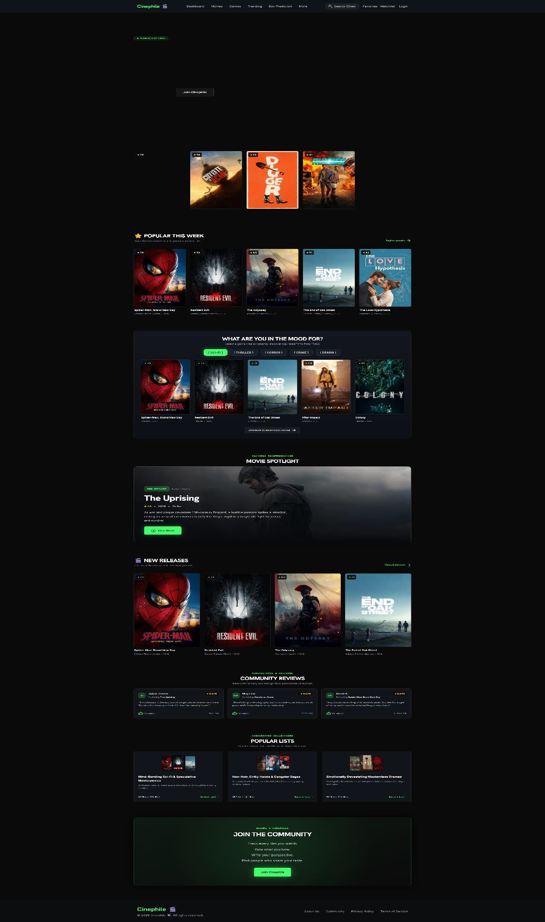

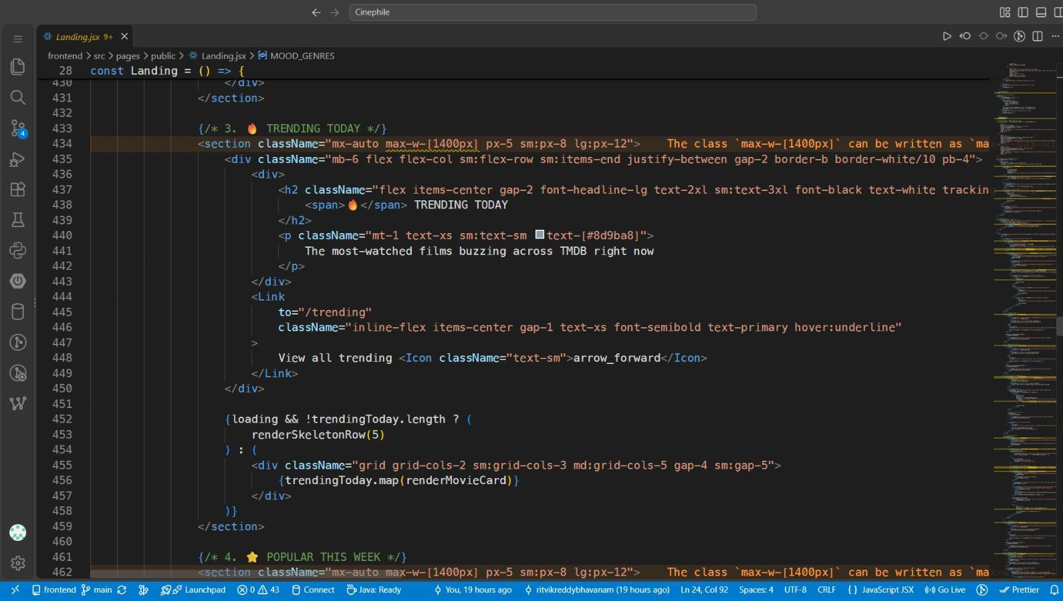
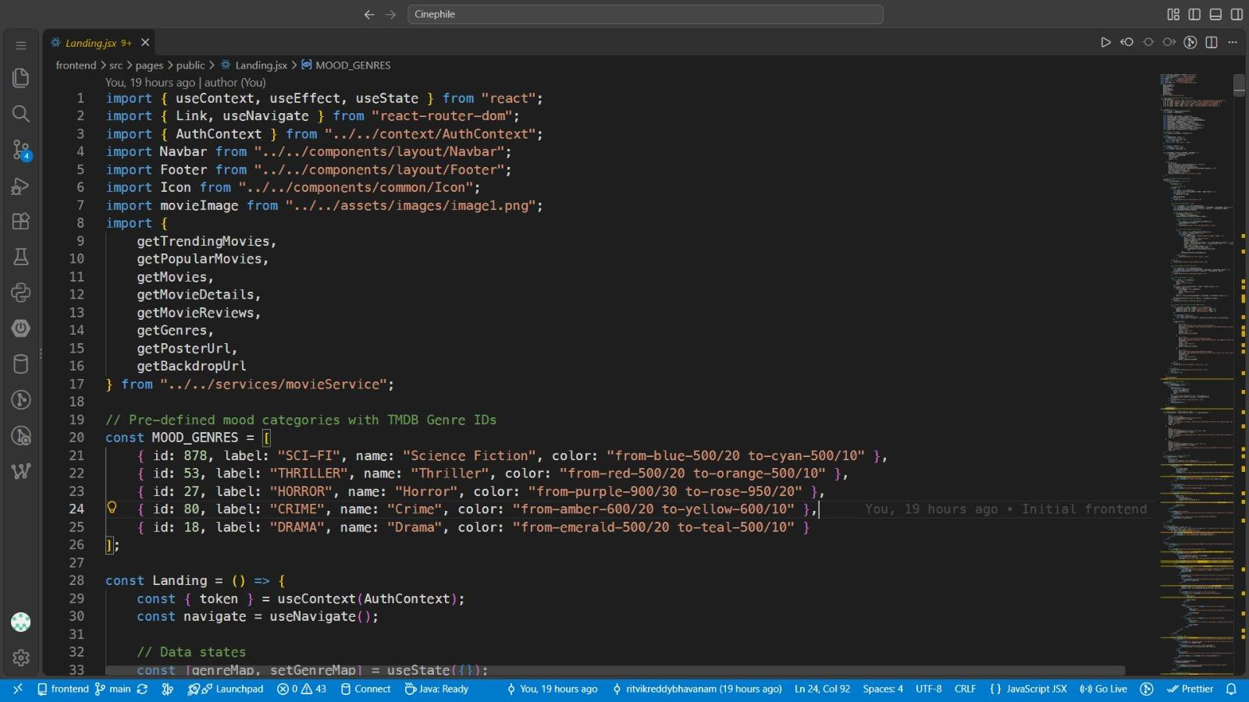Sample code snippets

Installation / Setup Instructions

The Cinephile Movie Discovery Platform is a full-stack web application developed using React, Spring Boot, MySQL, Firebase, and the TMDB API. To install and run the application, first download or clone the complete Cinephile project folder and open it using Visual Studio Code or IntelliJ IDEA. Ensure that Node.js, npm, Java JDK, and MySQL are installed on the system. Create a MySQL database named film_buff and configure the database username, password, and connection details in the Spring Boot application.properties file. The required TMDB API token and Firebase configuration should also be configured before running the application. The backend can be started by opening a terminal in the backend directory and running the Maven Wrapper using mvnw.cmd spring-boot:run. The Spring Boot server runs on port 8080. For the frontend, open a separate terminal in the React project directory, install the required dependencies using npm install, and start the development server using npm run dev. The application can then be accessed through the local URL provided by Vite, usually http://localhost:5173. Both the frontend and backend should be running simultaneously for all application features to work correctly.

User Manual / Guide

When the Cinephile platform is opened, users are presented with a movie discovery interface containing navigation options such as Movies, Genres, Trending, Box Prediction, Favorites, Watchlist, Watched Films, My Reviews, Lists, Actors, and Directors. New users can register for an account, while existing users can log in to access their personalized features. Firebase is used for email verification during the registration process. After logging in, users can browse movies, search for specific titles, explore different genres, view trending movies, and open detailed movie pages. The movie details page provides information such as the movie poster, overview, release details, genres, cast and crew, trailers, and available watch providers using data obtained from the TMDB API. Users can like movies, add them to their watchlist, mark movies as watched, and write or view reviews. The platform also provides actor and director information, movie lists, recommendations, and a box-office prediction feature. All user-related movie activities such as likes, watchlists, watched movies, and reviews are managed through the Spring Boot backend and stored in the MySQL database. Overall, Cinephile provides an integrated movie discovery and management experience that combines a modern React interface with Spring Boot backend services, MySQL database storage, Firebase email verification, and TMDB movie data.

Geo Tag photos with guide

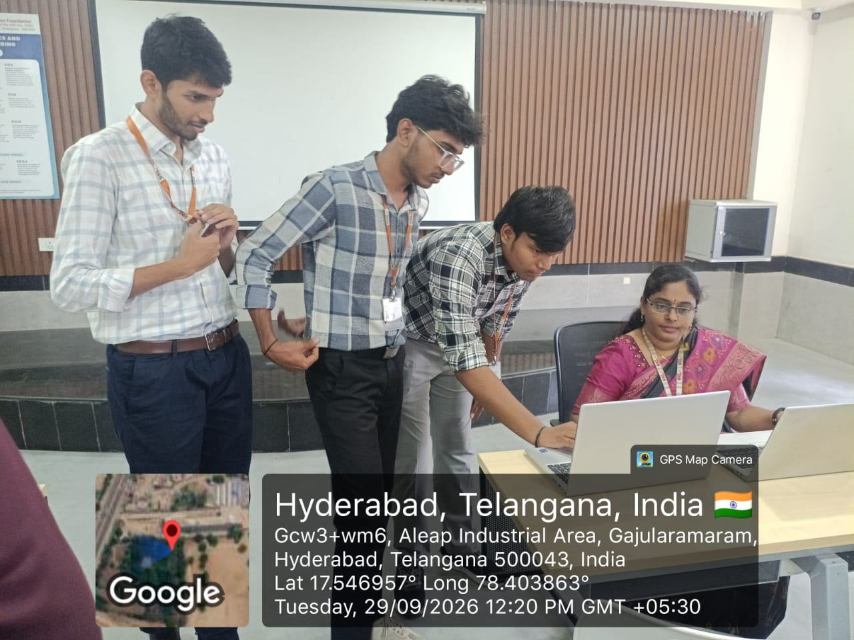

Review forms with guide signatures

